RESOLUTION NO. 2016-021

A RESOLUTION OF THE CITY COMMISSION OF THE CITY OF DANIA BEACH, FLORIDA, APPROVING THE SITE PLAN (SP-107-15), APPROVING A SPECIAL EXCEPTION (SE-17-16), AND APPROVING VARIANCES (VA-12-16), (VA-13-16), (VA-14-16), (VA-15-16) AND (VA-16-16) SUBMITTED BY BILL LAYSTROM, ESQUIRE, WITH DOUMAR, ALLSWORTH, LAYSTROM, VOIGT & ADAIR, ON BEHALF OF THE PROPERTY OWNER COHEN DANIA BEACH HOTEL, LLC D/B/A THE DESIGN CENTER OF THE AMERICAS, FOR PROPERTY LOCATED AT 1825 GRIFFIN ROAD IN THE CITY OF DANIA BEACH, FLORIDA AS LEGALLY DESCRIBED IN EXHIBIT “A’, A COPY OF WHICH IS ATTACHED TO THIS RESOLUTION; PROVIDING FOR CONFLICTS; FURTHER, PROVIDING FOR AN EFFECTIVE DATE.

WHEREAS, Bill Laystrom, Jr. of Doumar, Allsworth, Laystrom, Voigt & Adair, on behalf of Cohen Dania Beach Hotel, LLC d/b/a The Design Center of the Americas (the “Applicant”), is requesting site plan approval, approval of a special exception, and five (5) separate variances for the redevelopment of Le Meridian Hotel located at 1825 Griffin Road in the City of Dania Beach, Florida (the “City”), as legally described in Exhibit “A”; and
WHEREAS, the City Code of Ordinances, Chapter 28 “Land Development Code” (the “LDC”), Part 6 “Development Review Procedures and Requirements,” Article 635 “Site Plans”, Section 635-20(A), provides that site plan approval is required as a condition to the issuance of a building permit; and
WHEREAS, Article 630 of the LDC entitled “Special Exception Uses” states that the City Commission may grant a special exception based on its determination that the petitioner has demonstrated that the necessary criteria in the LDC have been satisfied; and
WHEREAS, the Applicant is requesting special exception approval to permit a hotel in a commercial zoning district; and
WHEREAS, Part 6 of the LDC, Article 625, entitled “Variances”, Section 625-40 states that the City Commission may grant a variance based on its determination that the petitioner has demonstrated that the necessary criteria identified in the LDC have been satisfied; and
WHEREAS, the Applicant is requesting a variance approval from LDC Section 275-100(C) to permit the removal of certain intermediate landscape peninsulas and the retention of other nonconforming intermediate landscape peninsulas (VA-12-16); and
WHEREAS, the Applicant is requesting a variance approval from LDC Section 275-100(D) to permit terminal landscape peninsulas of approximately nine (9) feet in width where ten (10) feet in width is required (VA-13-16); and
WHEREAS, the Applicant is requesting a variance approval from LDC Section 275-100(E) to permit the retention of the existing landscaping abutting the buildings where a minimum of ten (10) feet of landscaping abutting the buildings is required (VA-14-16); and
WHEREAS, the Applicant is requesting a variance approval from LDC Section 505-120(O) to allow two (2) wall signs where only one (1) wall sign is permitted (VA-15-16); and
WHEREAS, the Applicant is requesting a variance approval from LDC Section 510-30(H) in order to permit twenty-seven percent (27%) glass coverage on the ground floor of the building where a minimum of thirty-five percent (35%) glass façade is required on the ground floor of the building (VA-16-16); and
WHEREAS, staff recommended approval of the proposed Site Plan (SP-107-17), Special Exception (SE-17-16), and Variances (VA-12-16), (VA-13-16), (VA-14-16), (VA-15-16) and (VA-16-16) in its report dated March 8, 2016; and
WHEREAS, public notice was provided in accordance with law; and
WHEREAS, the City Commission finds that the approval of the Site Plan (SP-107-15), Special Exception (SE-17-16), and Variances (VA-12-16), (VA-13-16), (VA-14-16), (VA-15-16) and (VA-16-16) will protect the health, safety, and welfare of the residents of the City, and furthers the purpose, goals, objectives and policies of the City Comprehensive Plan.
NOW, THEREFORE, BE IT RESOLVED BY THE CITY COMMISSION OF THE CITY OF DANIA BEACH, FLORIDA.
Section 1. Recitals. The foregoing “WHEREAS” clauses are ratified and confirmed as being true and correct and they are made a specific part of this Resolution.
Section 2. Approval of Site Plan (SP-107-15). Pursuant to Chapter 28 “Land Development Code,” Part 6 “Development Review Procedures and Requirements,” Article 635 “Site Plans,” the following Site Plan (SP-107-15), attached as Exhibit “B,” which is made a part of and incorporated into this Resolution by reference, is hereby approved.
Section 3. Approval of Special Exception (SE-17-16). Pursuant to Chapter 28 “Land Development Code,” Part 6 “Development Review Procedures and Requirements,” Article 630 “Special Exception Uses,” the application for Special Exception Use (SE-17-16), a copy of which is attached as Exhibit “C”, which is made a part of and is incorporated into this Resolution by this reference, is hereby approved.
Section 4. Approval of Variances (VA-12-16), (VA-13-16), (VA-14-16), (VA-15-16) and (VA-16-16). Pursuant to Chapter 28 “Land Development Code,” Part 6 “Development Review Procedures and Requirements, “ Article 625 “Variances,” the following applications for Variances (VA-12-16), (VA-13-16), (VA-14-16), (VA-15-16) and (VA-16-16), a copy of which is attached as Exhibit “D”, which is made a part of and is incorporated into this Resolution by this reference, is hereby approved.
Section 5. Conditions. The approvals granted by this Resolution are subject to the Applicant’s compliance with the following conditions:
1. Applicant shall provide traffic statement of additional trip generations using the latest ITE generation rates.
2. Applicant shall provide geometric dimensions for all proposed driveways, parking stalls, turning radius, etc.
3. Applicant shall provide drainage calculations.
4. Applicant shall show sight triangle at existing ingress/egress- this must be reflected on the landscaping plan using FDOT Index 546 for guidance.
5. Pursuant to City Code (Article 415 – Sidewalks and Swales), the Applicant shall be responsible for sidewalks and swale improvements located within the right-of-way.
6. Applicant shall provide a projection of water demand, sewage and solid waste generation in tabular format in compliance with Article 805 of the City Code.
7. Applicant shall provide as part of the final submittal a drawing file (dwg or dgn) disk of the approved site plan in Florida State Plane Coordinate (NAD 83).
8. Applicant shall provide “No Parking” signs and yellow painted curbs in the fire lane to the satisfaction of BSO Fire.
9. Applicant shall provide a copy of the approved set of plans in .pdf format via email to kennethsean_brown@sheriff.org . If the plan set is too large to send through email, please deliver the plans in .pdf format on a CD-ROM to Attn. Chief Brown, Fire Marshal’s Office, 103 West Dania Beach Boulevard, Dania Beach, FL 33004.
10. Applicant shall provide a letter from Broward County identifying whether the subject property requires platting or re-platting. Pursuant to City Code Section 605-30(F), the Applicant must provide “the recorded plat and any agreements modifying the plat (example: amendment to the restrictive note or NVAL), if the subject property has been platted.
11. Pursuant to City Code Section 635-50(I), the Applicant shall identify “locations and dimensions of all existing and proposed right-of-way and dedications, including ultimate right-of-way lines (if applicable)”.
12. Applicant shall identify projected water demand for the proposed project.
13. Applicant shall be required to pay all applicable Impact Fees as provided on 10-19-15.
14. Pursuant to City Code Section 635-50(S), the Applicant shall provide “location, character, size, height and orientation of proposed signs, including building signage details shown on plan elevations and the method of illumination”. Pursuant to City Code Section 505-120(B), the Applicant shall provide an address sign.
15. Pursuant to City Code Section 265-50(3), the Applicant is required to satisfy all parking standards and requirements. All drawings shall accurately reflect the required and proposed number of parking spaces.
16. Applicant shall not permit the long-term or short-term storage of vehicles on the subject property.
17. Pursuant to City Code Section 265-120(B), the Applicant shall provide a valet parking agreement that identifies “…the number and location of parking spaces reserved for valet parking, and shall require that any use of property for which valet parking is provided in order to satisfy the required number of parking spaces shall cease immediately if for any reason the valet service is not provided at all times during the operation of the uses for which the parking is provided”. Pursuant to City Code Section 265-120(B), the site plan shall delineate valet podium, signage and attendant-parking spaces, and provide an adequate number of stacking spaces for the drop-off area without blocking crosswalks.
18. Applicant shall have the proposed project reviewed by the Broward County Aviation Department and Federal Aviation Administration as applicable.
19. Pursuant to City Code Section 265-51, the Applicant shall provide the minimum bicycle parking requirements.
20. Pursuant to City Code Section 510-30(H), the Applicant shall provide detailed drawings demonstrating the glass façade on the primary elevation is between the heights of two feet six inches (2.5’) and eight feet (8’) above grade.
21. Applicant shall identify how the proposed project is compatible with the existing Development of Regional Impact (DRI).

Section 6. Violation of Conditions. Failure to adhere to the terms and conditions of approval above shall be considered a violation of the City Code and persons found violating the conditions shall be subject to the penalties prescribed by the City Code, including but not limited to, the revocation of the approvals granted by this Resolution. The Applicant understands and acknowledges that it must comply with all other applicable requirements of the City before it may commence construction or operation, and this Resolution may be revoked by the City Commission at any time upon a determination that Applicant is not in compliance with the City Code.
Section 7. Site Plan Expiration. Pursuant to Section 635.100 “Expiration of Site Plans” of the Land Development Code, the Site Plan (SP-107-15) approval shall automatically expire and become null and void unless the Applicant files a complete building permit application with construction drawings for the improvements shown on the Site Plan, within eighteen (18) months from the date of this Resolution.
Section 8. Expiration of Special Exception. Pursuant to Section 630-70 “Expiration of Special Exceptions” of the Land Development Code, the Special Exception (SE-17-16) shall automatically expire and become null and void unless the Applicant files a complete building permit application with construction drawings for the improvements shown on the Site Plan within eighteen (18) months from the date of this Resolution.
Section 9. Expiration of Variances. Pursuant to Section 625-50 “Expiration of Variances” of the Land Development Code, the Variances (VA-12-16), (VA-13-16), (VA-14-16), (VA-15-16) and (VA-16-16) shall automatically expire and become null and void unless the Applicant files a complete building permit application with construction drawings for the improvements shown on the Site Plan within eighteen (18) months from the date of this Resolution.
Section 10. That the issuance of a development permit by a municipality does not in any way create any right on the part of an Applicant to obtain a permit from a state or federal agency, and does not create any liability on the part of the municipality for issuance of the permit if the Applicant fails to obtain requisite approvals or does not fulfill the obligations imposed by a state or federal agency, or undertake actions that result in a violation of state or federal law.
Section 11. Conflicts. That all resolutions or parts of resolutions in conflict with this Resolution are repealed to the extent of such conflict.

Section 12. Effective Date. That this Resolution shall be in force and take effect immediately upon its passage and adoption.
PASSED AND ADOPTED on __________________, 2016.

ATTEST:

LOUISE STILSON, CMC MARCO A. SALVINO, SR.
CITY CLERK MAYOR

APPROVED AS TO FORM AND CORRECTNESS:

THOMAS J. ANSBRO
CITY ATTORNEY
EXHIBIT "A"
LEGAL DESCRIPTION
See Attached
7
INSTR # 112422629, OR BK 50952 PG 1736, Page 3 of 6

EXHIBIT "A"
LAND DESCRIPTION
PROPERTY CONVEYED TO COHEN DANIA BEACH HOTEL LLC
A portion of Parcel "A", Design Center/Hotel/Office Complex, according to the Plat thereof as recorded in Plat Book 118, Page 11, of the Public Records of Broward County, Florida, described as follows:
Commencing at the Southeast Corner of said Parcel "A", thence South 88°39'27" West (Plat bearing), along the South boundary of said Parcel "A", 262.50 Feet; Thence departing said South Boundary, North 01°20'33" West, 224.83 Feet; Thence South 88°39'27" West, 120.67 Feet to the Point of Beginning; Thence continue South 88°39'27" West, 1.83 Feet; Thence North 01 '20'33" West, 122.50 Feet; Thence North 88°39'27" East, 1.83 Feet; Thence South 01°20'33" East, 122.50 Feet to the Point of Beginning.
Said lands lying in the City of Dania Beach, Broward County, Florida containing 225 Square feet, more or less.

610474/1/WESTPALMBEACH

EXHIBIT "B"
SITE PLAN
See Attached
8
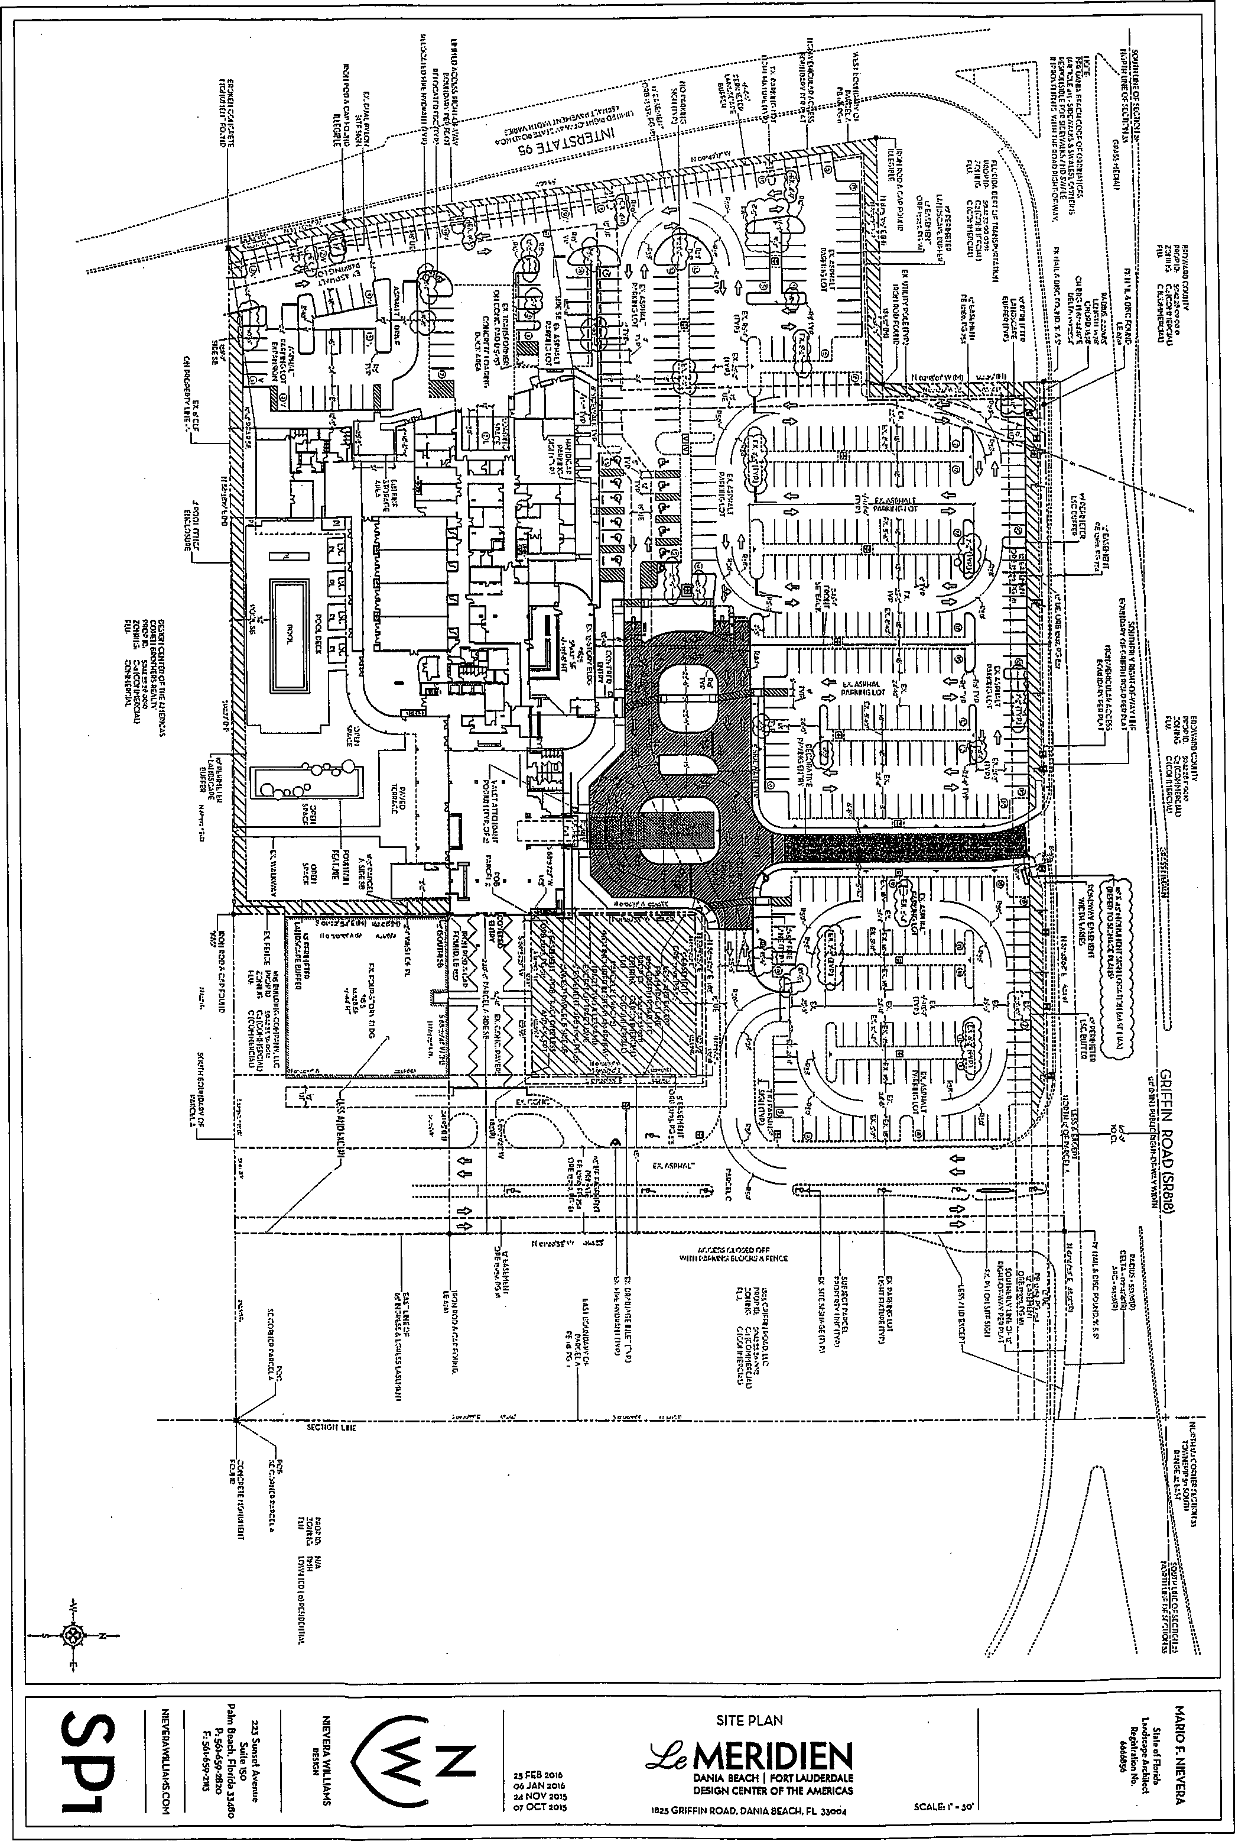
MERIDIEN
DANIA BEACH 1 FORT LAUDERDALE
DESIGN CENTER OF 1HF AMERICAS
IO25 GRIFFIN ROAD. DANIA BEACH, FL 30002
Rs FRB Role RR JAN 2010 24 NOV 2.5 07 OCT aRI5
..................
EXHIBIT "C"
Special Exception
See Attached
9


City of Dania Beach, Florida
Department of Community Development
Planning and Zoning Division
(954) 924-6805 X3643
(954) 922-2687 Fax

Standard Development Application
- Administrative Variance
- Land Use Amendment
- Plat
- Rezoning Date Reed:
- Site Plan Special Exception Petition No.:
- Variance
GI Other: (SEE APPLICATION TYPE SCHEDULE ON PAGES 3 & 4)
THIS APPLICATION WILL NOT BE ACCEPTED UNTIL IT IS COMPLETE AND SUBMITTED WITH ALL NECESARRY DOCUMENTS. Refer to the application type at the top of this form and 'Required Documentation" checklist to determine the supplemental documents required with each application.
For after the fact applications, the responsible contractor of record shall be present at the board hearing. Their failure to attend may impact upon the disposition of your application. As always, the applicant or their authorized legal agent must be present at all meetings. All projects must also obtain a building permit from the City Building Division. For more information please reference the Dania Beach Land Development Code Part 6, Development Review Procedures and Requirements.
Location Address: 1825 Griffin Road
Lot(s): Parcel B Block: Subdivision: Plat Book 118 Page 11
Recorded Plat Name: Design Center Hotel/Office Complex
• Parcel B of the Design Center Hotel/Office
Folio Number(s): 5042-33-36-0010 Legal Description: Complex Plat (Plat Book 118, Page 11',
Applicant/Consultant/Legal Representative (circle one) C. William Lays trom, Jr. Address of Applicant: 1177 S .E . 3rd Avenue, Fort Lauderdale, FL 33316
Business Telephone: ⁹⁵⁴⁻²⁷⁰⁻³²²⁶ _{Home:} 954-581-1738 E-mail address: blaystrom@aol.com |  | Fax: 954-525-3423
Name of Property Owner: Cohen Dania Beach Hotel LLC Address of Property Owner: 1825 Griffin Road
Business Telephone: 954-762-3400 Home: Fax:
The existing hotel is a special exception, which was Explanation of Request: never formally approved. For Plats please provide proposed Plat Name for Variances please attach Criteria Statement as per Section 625.40 of the Land Development Code,
Prop. Net Acreage: Gross Acreage: Prop. Square Footage: 569,597
Existing Use: Hotel Proposed Use: Hotel
1 of 4
Is property owned individually, by a corporation, association, or a joint
venture?
AUTHORIZED REPRESENTATIVE
I/we are fully aware of the request being made to the City of Dania Beach. If I/We are unable to be present, I/we hereby authorize
(individual/firm) to represent me/us in all matters related to this application. I/we hereby acknowledge that the applicable fee was established to offset administrative costs and is not refundable.
I/we are fully aware that all approvals automatically expire within 12 months of City of Dania Beach Planning and Zoning Board or City Commission approval, or pursuant to the expiration timeframe listed in Part 6 of the Dania Beach Land D elopm t Code.

STATE OF FLORIDA COUNTY OF BROWARD The foregoing instrument was acknowledged

(Owner / Agent signature*

^{71‘}

BEFORE ME THIS DAY OF 20 ^{1(.}°

By:

C. William Laystrom, Jr.
(Print name of person acknowledging)
(joint owner signature if applicable)
Notary 41drittnyv-ed f⁻4r:"rlraeTs;⁻- (Signature of Notary Public — State of noricia.
lti^{l}Vf",- KATHERINE FIO8ERT8ON
MY COMMISSION # FF131121 *. 41 EXPIRES: July 19, 2018
Aija, Bonded Thn, Notary PAW Undenniters

Personally known e or Produced Identification
2 of 4
Type of identification produced: or Drivers License
*If joint ownership, both parties must sign. If partnership, corporation or association, an authorized officer must sign on behalf of the group. A notarized letter of authorization from the owner of record must accompany the application if an authorized agent signs for the owner(s).
NO APPLICATION WILL BE AU'TOMATICALLY SCHEDULED FOR A MEETING.
ALL APPLICATIONS MUST BE DETERMINED COMPLETE BY STAFF
BEFORE PROCESSING OCCURS.

City of Dania Beach
APPLICATION TYPE AND PEE SCHEDULE
3 of 4
INCOMPLETE SUBMITTALS ARE NOT ACCEPTABLE FOR REVIEW AND PROCESSING.
The following fees shall apply to all applications for land use plan amendments, rezoning, special exception use, variances, site plans and other zoning related applications. These fees are used to defray staff cost in the evaluation of the proposal made and provide for the required notices and public advertisements according to Florida State Statute and the Dania Beach Land Development Code. Should any applicant have more than one type of request to the City, the applications involved should be submitted at the same time. The present City policy is to have concurrent reviews being processed before the final review and actions by the Planning and Zoning Board and/or City Commission. It is the obligation of all applicants to review the appropriate City Codes and design standards related to their proposal before making any application to the City. The standard review process for all development applications are two (2) review cycles. Any additional review or public notice required by staff or professional consultants due to the incorrect interpretation of the Land Development Code will be charged to the applicant as per "Section 685-10 Cost Recovery for Development Review" of the Dania Beach Land Development Code.
APPLICATION TYPE |  | FEE
LAND USE
Assignment of Flex Units or Acreage |  | Filing fee = $4,000.00 plus $5.00 per flex, reserve or LAC/RAC unit or hotel room or $100 per acre or portion of such area  Includes Staff processing, 2 review cycles, advertising and notice costs
Change of Land Use |  | Filing fee = $7,000.00, plus $500.00 per acre or portion of area Includes Staff processing, 2 review cycles, advertising and notice costs
ZONING
Change of Zoning (Rezoning) |  | Less than 2 acres - $2,500.00.  Greater than 2 acres - $6,000.00  Includes Staff processing, 2 review cycles, advertising and notice costs
Zoning Code Text Change |  | Changing the list of Permitted Uses - $6,000.00  General Text - $2,000.00  Includes Staff processing, 2 review cycles, advertising and notice costs
PLAT . |  | (Perimeter) Filing fee = $2550.00 plus $50.00 per acre or portion of such area  (Subdivision) Filing fee = $2550.00 plus $100 per acre or portion of such area Includes Staff processing, 2 review cycles, advertising and notice costs
Delegation Request |  | $1,500.00  Includes Staff processing, 2 review cycles, advertising and notice costs
SITE PLAN
Residential, Hotel, Condo-liotel, Time-Share, Motel |  | Filina fee = $1,000.00 PLUS $10.00 per unit
Residential, Hotel, Condo-liotel, Time-Share, Motel |  | Plus retainer for staff/consultant review, administrative and notice cost $5,000.00
Residential, Hotel, Condo-liotel, Time-Share, Motel |  | Minimum fee = $6,100.00  Includes Staff processing, 2 review cycles, advettising and notice costs
All other uses |  | Filing fee = $1,000.00 PLUS the following:
All other uses |  | $5.00 : 100 s.f. for 1st 10,000 s.f., $2.00 : 100 s.f. in excess of 10,000 s.f  Plus retainer for staff/consultant review, administrative and notice cost $4,000.00
All other uses |  | Minimum fee = $5,500.00  Includes Staff processing, 2 review cycles, advertising and notice costs
Site Plan Revisions |  | $2,500.00 - Includes staff processing and up to 2 review cycles.  Additional variances associated with any revisiOn to a site plan are charged according to the associated variance type.
Extension of Approval(s)(Site plan, variance, special exception requests) | • | $1,²⁵⁰.⁰⁰ — Single Extension (PLUS) an additional $ 250.00 for each associated approval

City of Dania Beach
APPLICATION TYPE AND FEE SCHEDULE
INCOMPLETE SUBMITTALS ARE NOT ACCEPTABLE FOR REVIEW AND PROCESSING.
The following fees shall apply to all applications for land use plan amendments, rezoning, special exception use, variances, site plans and other zoning related applications. These fees are used to defray staff cost in the evaluation of the proposal made and provide for the required notices and public advertisements according to Florida State Statute and the Dania Beach Land Development Code. Should any applicant have more than one type of request to the City, the applications involved should be submitted at the same time. The present City policy is to have concurrent reviews being processed before the final review and actions by the Planning and Zoning Board and/or City Commission. It is the obligation of all applicants to review the appropriate City Codes and design standards related to their proposal before making any application to the City. The standard review process for all development applications are two (2) review cycles. Any additional review or public notice required by staff or professional consultants due to the incorrect interpretation of the Land Development Code will be charged to the applicant as per "Section 685-10 Cost Recovery for Development Review" of the Dania Beach Land Development Code.
SPECIAL EXCEPTION
SPECIAL EXCEPTION Excludins cell towers | Filing fee = $3,700.00 plus $200.00 per acre or portion of such area Includes Staff processing, 2 review cycles, advertising and notice costs
SPECIAL EXCEPTION | Filing fee = $4,000  Includes Staff processing, 2 review cycles, advertising and notice costs
Additional Resubmittal Any additional review or public notice required by staff or professional consultants due to the
(In addition to the standard (2) review cycles) negligence of the applicant will be charged to the applicant as per Article 685-10 Cost recovery
for Development Review of the Dania Beach Land Development Code.
VARIANCES, APPEALS & WAIVERS
Administrative, Single Family i 300.00
Administrative, all other i 500.00
Single Family/Community Facility $ 490.00
Duplex $1,050.00
Triplex $1,150.00
Multifamily, Hotel, Condo-Hotel (per
variance) $2,300.00
Nonres. (per variance) $2,000.00
Wall Sign $ 700.00
Monument Sign s1,200.00
Pole Sign (As permitted) $2,400.00
Appeal (single family & comm fac) $ 650.00
Appeal (all other uses) $1,925.00
Dumpster Appeal to Corn. Dev. Dir. $ 200.00 .
Dumpster Appeal to City Corn. $ 500.00
Alcoholic Beverage Variance $1,250.00
Mobility $1,400.00
Trafficway Waiver $4,000.00
Vacation — Road/Easement 53,500.00
Alcohol Extended Hours
License Application $2,250.00
Alcoholic Beverage Waiver $1,000.00
Zoning Review: State Liquor License $ 50.00
Outdoor Seating/Dinninq $ 100.00
Assisted Living Facility $ 65.00
CRA Grant Application $ 800.00 (up to this amount based on scope of work)
UNSPECIFIED $ 500.00 PLUS any outside costs incurred by the city as per "Section |  | 685-10"

Revised— 8-23-11 As per City Commission Approval Resolution #2011-090
4 of 4

LAW OFFICES
DOUMAR, ALLSWORTH, LAYSTROM,
VOIGT, WACHS & ADAIR, LLP

1177 SOUTHEAST THIRD AVENUE
FORT LAUDERDALE, FLORIDA 33316-1109
BROWARD (954) 762-3400
TOLL FREE (866) 242-9488
TELEFAX (954) 525-3423
WEBSITE: SFLALAW.COM
BENJAMIN R. DISHOWITZ, P.A.
RAYMOND A. DOITMAR, P.A.*
C. WILLIAM LAYSTROM, JR., P.A.
JOHN D. VOIGT, P.A. JEFFREY S. WACHS, P.A.+
OF COUNSEL
JOHN W. PERLOFF, P.A. JODIE SIEGEL, P.A.
JOHN H. ADAIR, Tr', P.A. EMERSON is WORTH, P.A. E. SCOTT A_LLSWORTH, P.A. IVIARK E. ALLSWORTH, P.A.
+ALSO ADMITTED IN PENNSYLVANIA ',FORMERLY ADMITTED IN MICHIGAN

December 29, 2015
Since the hotel is an existing use, it has already been proven that it will not have a detrimental impact to the
Re: DCOTA Hotel Renovation- Special Exception Use Approval
COHEN DANIA BEACH HOTEL, LLC
RESPONSES TO CRITERIA FOR SPECIAL EXCEPTION USE APPROVAL
The Applicant currently has an application pending to amend the site plan of the existing Sheridan Hotel located at 1825 Griffin Road to provide for both interior and exterior remodeling and to re-brand the hotel as Le Meridien Hotel. As part of this site plan amendment process, the staff has identified one or more variances which the Applicant will need to seek in order to accomplish this new plan.
Specifically, it has been determined that the hotel use is a special exception use in this zoning district. Although the hotel was obviously approved, it appears that the special exception was never specifically granted, and the Applicant seeks to rectify this oversight. As part of this request for special exception use approval, the City must consider as part of its determination the following criteria:
- That the use is permitted as a special exception use as set forth in the use regulations of Part 1 of this code;
The use is permitted in the use regulations of Part 1 of the code.
- That the use will not cause a detrimental impact to the value of existing contiguous uses, uses in the general area, and to the zoning district where it is to be located;

value of contiguous uses and to the zoning district where it is located.
- That the use will be compatible with the existing uses on contiguous property, with uses in the general area and zoning district where the use is to be located and compatible with the general character of the area, considering population density, design, scale and orientation of structures to the area, property values and existing similar uses or zoning;
Again, since the hotel is an existing use, it has been shown conclusively that it will satisfy this portion of the criteria, and that it is a compatible use with the surrounding areas.
- That adequate landscaping and screening are provided to buffer adjacent uses from potential incompatibilities;
The landscaping is being improved as part of the site plan modification application. Since it is an existing hotel use, the existing landscaping has been deemed adequate as a buffer.
- That adequate parking and loading is provided, and ingress and egress is so designed as to cause minimum interference with traffic on abutting streets;
Since this is an existing hotel use with only a site plan modification, the Applicant is ensuring that the adequate parking that is existing will remain.
- That the use will not have a detrimental environmental impact upon contiguous properties and upon properties located in the general area or an environmental impact inconsistent with the health, safety and welfare of the community;
The hotel use will not have a detrimental environmental impact as has been shown in its years of existence.
- That the use will not have a detrimental effect on vehicular or pedestrian traffic, or parking conditions, and will not result in the generation or creation of traffic inconsistent with the health, safety and welfare of the community;
Since it is an existing hotel use that is not being enlarged, but rather only modified and improved, the impact on vehicular and pedestrian traffic, parking and the like will not change.
(8) That the use will not utilize turning movements in relation to its access to public roads or intersections, or its location in relation to other structures or proposed structures on or near the site that would be hazardous or a nuisance;
The traffic flow pattern is not changing from the existing use, so this portion of the criteria should already be satisfied.
(8) That the use will not have a detrimental effect on the future development of contiguous properties or the general area, according to the comprehensive plan;
There •is nothing to suggest that a hotel use will have a detrimental impact on future development, but rather should help encourage future development with the remodeling and upgrades being provided by the Applicant.
- That the use will not result in the creation of incompatible noise, lights, vibrations, fumes, odors, dust or physical activities, taking into account existing uses, uses located on contiguous properties, uses in the general area and the zoning in the vicinity due to its nature, duration, direction or character;
Since the use is already existing and is not being enlarged, the Applicant would submit that it has already met this portion of the criteria.
- That the use will not overburden existing public services and facilities.
Since the use is already existing and is not being enlarged, the Applicant would submit that it has already met this portion of the criteria.
Respectfully submitted this | 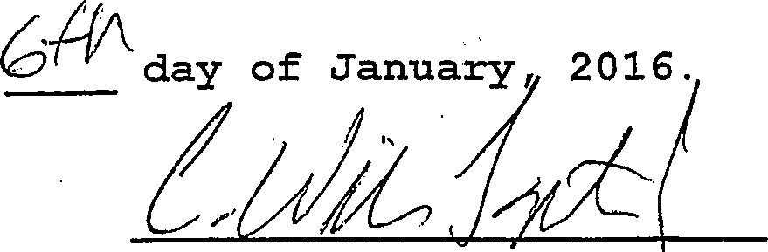
 | C. WILLIAM LAYSTROM, JR.

- MITI

[I • 'ITEMS CORRESPONDING1DSCHEDLJEE 11.-1111
®
no....160.4.1Intle...774 {kb poc.1.,T. sea 11, 1110.11:1101.1.111 TNESURVERIIPPOPISI.AMIMAITIMLW..1.01.0.31.
® • tv, ard .1 bash...a.m./
er....01007.**1 bat COM. pp.., pi ob. mer.o.k. Mr.realgoletass Wile* re./.41.0../.1....5, Moth...VIM an=
roonsco•grem..,.../..y......c.. 111...1...MTPC UMW= PROM¹17.110MMATIOXI.V914.17113.1•CSMATITINea.
0
Nada pa/ nos nsal /ATM TH SYRYLISH PROHHOTAMOIMMIS011e WNW hebtax.
weal*.
® .41320....,asnaMPIXItliNearamo.110.,... V.A.. I,* p. 17010.6911..MenSOPPS•01.13011.141719MIMM...../
⁰ EETh
₀ la put
vow Hra.Cead lema0Hit ne. Med Hass S.
Poe.a.Appe MOW Ras .1,149,19.11.
laamacesms.
TNISM:¹1.11.1111MNICUOPPOP0117.117.4e110111.COSII011.079.ME
¹¹.Turekoma.a.,*.............i.n.n.none Yete(fts.esmos eds.0.¹1Vgbikassey.11...../..e....11.11411140.01114.1.00.PA
H.* casubmas*How. pa* Pas.
caw Heed.
Hearnall.Haxeml neFCHIS Ha Humane subon.s.
111....a.mona.lansameana row.. ex..... Coo. Ira...a sea
(G.)
v........casHavasoa Imam. ng Wk.
namMtrelloi cuRanconterun,smavornicHC.Ma martsaa sway
0 amp
0.0.1.0 Unlasee...nmaa bond Rusesewurriorn
¹....P..¹....)11⁴.1100³M1111.111114VMGDPROPCRINCIOn..71112 CHTIMMICCM.
INFORMATiON r,
7.21.1MILIORY0.5)67,111.E.433.111.120X2.101WORLYTMPROIATM•1201.011,121.147713. TAALLARSIA10.
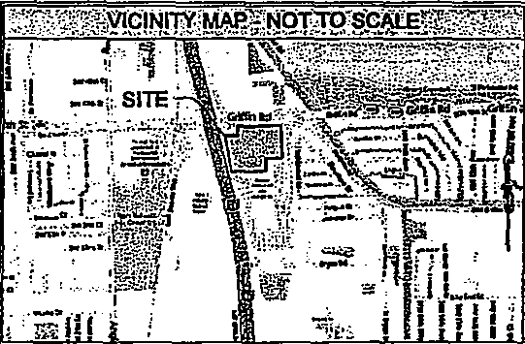
II 7, ,V.MNISIOECIMEOUSNOTEV::⁻'"
n•⁻;,,,
TO t! 10 ONCOH/RatC,A11711HE HIIIHOHDCATIO
PLIOLICP.R.C.F.VAY.UPC.0.11.00.41.
scHC rum.= aKom rigs iv., taw DE mom cat. avic 1, CLwir..
- catenutli.....0/20Vgaccestax.1.‘“ NERELOCklui CD whom. MILMFANIA.SIOTIGNIOAD.UWERIIIESCOPECf ZOO tAUt?. C) Mann,. BOW DM THE W. HAM POHOPSWIMOIIIEnraCCOarnaln.
nova,.
incss cumonans. ovent.us mmnat xxcHertIo Ix a...
Ms.. foam MEM,. IMSIECHHITH DAM, PICHHCCWAYLDECf
TOUT P
C) MADCAP. (X H. MORN Haw VAS ecalta anla =Meng Mbar. .₀.1HCYJR,H1131.,....H1011.10V CONTAMIHAPSACHHOMAGIS HICHSSCHMEMO.
- 1.1.181A1P02 =owl Mama SHOHAM is snollOicuos...03
CD PAIIKNOSPACESFORATI7IN...SINIPOPMENOSPKOMIIONESAIVE111,
(B) THS Myr( OUOTSITDUt! POP coMituCIWIal comEntuHrniCeatat nom.. IIIEGIARZNIOISCOROPEVALTONS orm4acrouxuaKrtneovmeivro.. WINEYORPOI.2,111001.1.70.10.11110.-IMOUNDIPITSFOI Amami LHOIME SWIM. HITECTIVERONNI123.27.)
0 HD MISCH OR PAIRMILIHCPC DMA= INTECIADIralt LOWEIHIV
SUPS) RVahl RESAECT 10 AMAMI PACF0015.
r:ErOWIL :41111
COINIJOEMNERFeca IRMIN11.1.1:11.1141MITISOC.1.041..10.PX T. ...Mat Le.C...11,11011MICONIKIWIS.P.1.3Aso
MKT= PROPL.Y.I.P.c.MTAMILTYMIUILRINO3117.114.71....11. OA' (M12.011.11..
Arra Tut or Wrvey.THEla HLOgoo oasemeLEarcerA LY(SH Hama Haat MOM CONSMUCH0H
etMHZ MC of auRvIt Ho OlmenntX IVO°. csant cow . SHHIONI, HUloa. WIT* 1.41111najmnal =COMM csartICHY.
11¢. SVIC/LHDR Krt IHOVICCOANY 0.1.61CHICHatleAS Ham. Ave.. Ma cm 11171067P.MIAr C.01014.11.40.01111% SUINTICOPIPPCNIT.111...11.570 WHIAHOMCCHAHHNITCP In1011471.10 urypaNDITAL*00$0.‘Cavi. PCHORIMO.ThICIANCYCH FROMM HICOCHNOLV. COM
HICIZUHCHHI. WHIN! DisHUACI mi. MAMA Sr HocCium con...11011
.11.10.LACHIrt OISUCCIaMton VFICITHOuGHCarne
TEM. CP.81119,..COPINIPANKLIOBLIWYPINE.OLIMIRIALV...
RECORD DESCRIET1014
LEGEND OF SYMBOLSVABBREVIAllai1:'1
'ROJECTREVISIOK.RECORD:
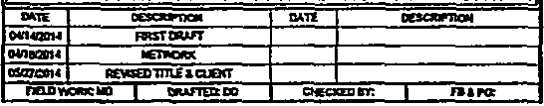
nut
CEIHRPTICSI
CHSCHIPTCY
0.1.101.1
FOIST WAR
OVIE721174
KINO:Ott
133,27C014
RE.51:0111123.0.1017
nno roma) I Hurl= CO
sticiamo Int I FBA rct
0
oJ Camp. us AL.Cce aHHHI.ve
e CA.MH
ft*11 MON MERV, 00 3.1.1 f.) WOW
SIGNIFICANFOBSERYATIOI6StirMinji
NOMEAPPN.T. BY BOCK It CLAM CORP.
cp Ma MOM.. CIEHICCIEDINCIVIIIMMCMCH.ILIDCHIS XRERESCINCO.
THEME .711.711.0.CHHHT IrtionlY PROHIMMIMCSITI14.111. COMM/.
143111.01101.0.SCIAUCOM
a caw. Harr rote
I---Huy tau ucHAL war
0 MOAK W.. ea VAULT
- SUCHHC 30001..211.0,
a UCCTICKlart
WAR
11,141310NIER
o AA COMMOWALIIIIT MOPett
(!) retenowocumagt t.q .1.111.1.12
11.31101[ MOM A /24411104.7
a was. C( 'HWY ruf Wawa (0 suonATED
6) =Mu alLY....Cat 0 voyEl Haw. PL.
- 3111/111178MPAti a PADOIDWPAZW.Mr. PG oHLE
S at pa...mpg
st120,
04431.AP S VPLLHVAO Pa Ka..
sum, mammas., LI.. Mart C(AuSfab QT. I IcsanALUNmapit
0 .2,308.12.11 ormuLsroSa
mono
eff Row001.1..011"
OH
' t`.¹⁰TE
IPIOIAMICP1.01114.011.1,IMPACOVATO *amt. CPT. MOD VOLVAISIPATE
W.P.LOIYA.Y116.12713.1.0.4•MIUM13711CMOOW.M.ORS.1.41341.01,11).ECf Al...17715.3PEMIMNAPOSO. 11.0201.2..D.,PAP.A.ISKPa• P.I1EVANCOM 0111,.....00/1IVP0111411ICK.IDOVAPRIL 11.701.1...1.11.1K0116 [MOM 001.312XMOMPAIMP.IIIIIIIK PleCt4.1.3111.0.1.17MIDOW. P0¹0.1:07¹21X1XISMETiaivoCAMAnCer.i...nalCINIVIC.1...2111.2.0 W.111PITLIOCIPOOL.01011.”-V MIA VLLWICEM01111.1.0...DERGOICT
70001110?Y011. Put.10:

11.1141,a.

.⁻tiRODEte*FetiON.
N.H.. Ha a ••• H,H.
IL NW ••••wwwalberp.Ilaaa......11.1.0
wrarcHt. ram a CHHH.
AHHOsun:
made sea
STYM...........1-132.*•*11........0 to
....,......,73rtry,104•• an a/ ewe gran ••••••,.......501.141..Elmoso* saarsollan.poup•avolla....10,CP...
112,44.0
Coanosift
HicH4
Gm*,
Toonwearent
CUIWIIC•scosanIto •.7
J

ALTAIAQSMIAND7,FITLE'SLIVEY:':::::'N
Sheraton at Ft. Lauderdale Airport Project
BIC Prtdoct No. 201400901, 001
Hotel
102500010? Road, Dents, FL
BASED UPDMI771- E ORDER 51.4754130
OF AMITY NATIONAI-TrILE INSURANCE COMPANY
BEARING AN EFFELTIVEOATE OF APRIL 9, 7004 1140 P.M.
U.C..dossei irdredutlikeceopnA 89.111.1.1 MG, a
'beim. **Mem so•Madaxliessunry an.......apbs. sm..= Hen.231, warn soopera OHM cawirea.s. ta/17404601....T.80.824)1H3 wariHHHHHHHHHHD0.1.TH.HIHISH....1.4 PH. 1.23.4.04 0..78,7e/.74 4 H.
Wra...1.001.11,.0...Psee00GU.S.1415
ALSR
I.waVtOBst000asrDOTUyfl⁰⁰⁰mS&GTVSCTHLOOIP⁾OARYUR^{S}OY REPRCSEHIEOKIMECHUEErSTEmaCIAMTECKHCALMHHARCet FORVORVEIHIGRA IlLESTATEOF RILCHAAS SECFCCHIMIIE RCM. DCOHOOFG.0SURVEYORS, CUICSUANTIPCMTHERPSOFTHEFLOROAsTATEIrEsAHO0ViTER Siff Oi 711C FLCHSCAAMOUSTROIVECCOE
PRELIMINARY
111.1XCD.1.857
ABIHSIIMMOHIMI.P.15.1
IHRESTMEOCIICHHOH
DTASWRAUDAUSOEZAPTO.14.UOO UM OF LASCREMetc 1..7.217H HEMORKPROJECTH0.2014.01-1
SURVEY PERFORMSCICH
DOM& CUMCC.P.1.21.7303
EMI B.H2EHOLSHIACVEH
SAPASCITAJI. TWO
P0elt037174335 01.1C(M1/3211.83
Ell.finUNCO6RCIO00500.0.02¹
THISSURVEYISCEIROMBOIDIMIE FOC SURVEY... CATE OF 64CANHARE. KfrVALKHAITHOUTIHESCOMURENOITECMCCHAL RASED SELL OF11
\,...11.7CAUGEHSED SUMMORNOSIAPPOL
9.71 OF
1100(C CLAM MHZ= 1.0.1=1100132
PDF created with ptilFacto4y Idol version 322ffagtmf.gm
onep..m. onsta Nal VH.CH sworlemeel•THIO.p.imsHOPHHHHH.H.H. NO3.1.10.0.ormr.a.a.no...13.10.o.Seat
nzio. n,5.USSaUI O5fltdlUT1.OTOd5UIA.OtA?t
Ifed.ounaroro.....miNnow Roaratant rant
upwrpnehmt.nnomv
roe. NI... Commis Hemecte CHHHCHIcroda.cr Hem., bpiespaane.1.810,10.
700012/Mliit
Tn.
eukatHear,
Hta Hal Wm.. of Hoar. NH* 01.446 aHnetortIRI,H11..* hboltme2.1424131,815(Mers<9.1.0mbellhowolta.......km.,Hor.q..., at.rft.....P.F.M.P•P.IVIONI
TM Win 3.1rMyco.e..0.01.14121.0.1001outellesumwasKoesalso
wenne mamma mama et mew mexu-Inammunzecarmr....o.
4:76,11.0ATEWP.9.9714.
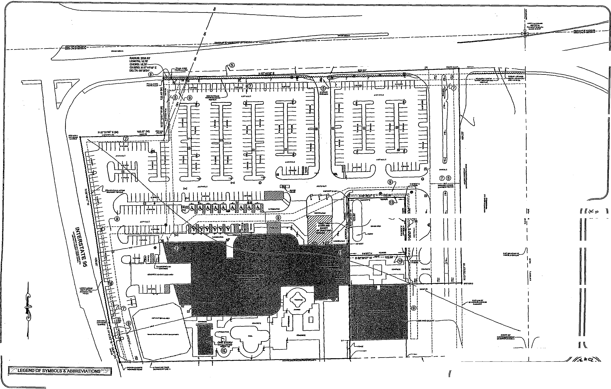

00.7

war.
NOWSSITEM

GRIFFIN ROAD
Itol....K.Mraro^{vome}
LESIINIOECCEPT
Wan. annternicza.
tus Aso Imcol
1
LIELSMOtsCOR
Mr. INK, ME
mu)
Z.14,
(DP 8
ID —I
A
=in
TriZ,_11
9..< tot) le;
(0.47rcg
nsui.;
84
0.°
06_ tF,
021,,
07,4
SCALE: V= Cr
MaTOI17.11ase.1
17...00111.•
AMESEPT
zAise rye
Au.
tre =Mt RA 1.07.0
PDF creabivithpainvoy nonien
=Tree
earalr•
PREPAF
(ALTA/ACSM LAND TITLE SURVEY )
Sheraton at Ft. Lauderdale Airport Project
0.41E OF RELOSURVEltAPRIL14,2014
NEWARK PRO.ECTNO.M400G014 SHEET20F2
EXHIBIT "D"
See Attached Variance Applications
(VA-12-16)
(VA-13-16)
(VA-14-16)
(VA-15-16)
(VA-16-16)
10

 | City of Dania Beach, Florida  Department of Community Development  Planning and Zoning Division  (954) 924-6805 X3643  (954) 922-2687 Fax

Standard Development Application
Administrative Variance
OODUDIJOD
Land Use Amendment
Plat
ReZOning Date Reed:
Site Plan
Special Exception Petition No.:
Variance
Other: (SEE APPLICATION TYPE SCHEDULE ON PAGES 3 & 4)
THIS APPLICATION WILL NOT BE ACCEPTED UNTIL IT IS COMPLETE AND SUBMITTED WITH ALL NECESARRY DOCUMENTS. Refer to the application type at the top of this form and "Required Documentation" checklist to determine the supplemental documents required with each application.
For after the fact applications, the responsible contractor of record shall be present at the board hearing. Their failure to attend may impact upon the disposition of your application. As always, the applicant or their authorized legal agent must be present at all meetings. All projects must also obtain a building permit from the City Building Division. For more information please reference the Dania Beach Land Development Code Part 6, Development Review Procedures and Requirements.
Location Address: 1825 Griffin Road Lot(s): Parcel B Block: Subdivision: Plat Book 118 Page 11
Recorded Plat Name: Design Center Hotel/Office Complex
Parcel B of the Design Center Hotel/Office Folio Number(s): 5042-33-36-0010 Legal Description: Complex Plat (Plat Book 118, Page 11)
Applicant/Consultant/Legal Representative (circle one) C. William Lays trom, Jr. Address of Applicant: 1177 S.E. 3rd Avenue, Fort Lauderdale, FL 33316
Business Telephone: ⁹⁵⁴⁻²⁷⁰⁻³²²⁶ _{Home:} 954-581-1738 E-mail address: blaystrom@aol.com | Fax: 954-525-3423
Name of Property Owner: Cohen Dania Beach Hotel LLC Address of Property Owner: 1825 Griffin Road Business Telephone: 954-762-3400 Home: Fax:
Three Landscape Variances from LDC 275-100
Explanation of Request: Sections (C),(D), and (E). See attached.
For Plats please provide proposed Plat Name for Variances please attach Criteria Statement as per Section 62540 of the Land Development Code.
Prop. Net Acreage: Gross Acreage: Prop. Square Footage: 569,597
Existing Use:Hotel Hotel Proposed Use:
1 of 4
Is property owned individually, by a corporation, association, or a joint
venture?
AUTHORIZED REPRESENTATIVE
I/we are fully aware of the request being made to the City of Dania Beach. If I/We are unable to be present, I/we hereby authorize
(individual/firm) to represent me/us in all matters related to this application. I/we hereby acknowledge that the applicable fee was established to offset administrative costs and is not refundable.
I/we are fully aware that all approvals automatically expire within 12 months of City of Dania Beach Planning and Zoning Board or City Commission approval, or pursuant to the expiration timeframe listed in Part 6 of the Dania each Land Dev opmen Code.
By:

STATE OF FLORIDA
COUNTY OF BROWARD The foregoing instrument was acknowledged
BEFORE ME THIS O DAY OF
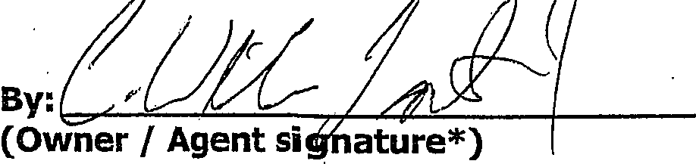
 | 20 I (⁰

C. William Laystrom, Jr.
(Print name of person acknowledging) (Joint owner signature if applicable)

Notary\⁴0-savtAl,,A-e-,' Rkcjeafi


KATHERINE ROBERTSON
MY COMMISSION # FF 131121
EXPIRES: July 19, 2018
Bonded Thru Notary Public Undeneftre
(Signature of Notary Public — State of ⁻\.bri⁻cle-

Personally known or Produced Identification
2 of 4
Type of identification produced: or Drivers License
*If joint ownership, both parties must sign. If partnership, corporation or association, an authorized officer must sign on behalf of the group. A notarized letter of authorization from the owner of record must accompany the application if an authorized agent signs for the owner(s).
NO APPLICATION WILL BE AUTOMATICALLY SCHEDULED FOR A MEETING,
ALL APPLICATIONS MUST BE DETERMINED COMPLETE BY STAFF
BEFORE PROCESSING OCCURS,

City of Dania Beach
APPLICATION TYPE AND FEE SCHEDULE
3 of 4
INCOMPLETE SUBMITTALS ARE NOT ACCEPTABLE FOR REVIEW AND PROCESSING.
The following fees shall apply to all applications for land use plan amendments, rezoning, special exception use, variances, site plans and other zoning related applications. These fees are used to defray staff cost in the evaluation of the proposal made and provide for the required notices and public advertisements according to Florida State Statute and the Dania Beach Land Development Code. Should any applicant have more than one type of request to the City, the applications involved should be submitted at the same time. The present City policy is to have concurrent reviews being processed before the final review and actions by the Planning and Zoning Board and/or City Commission. It is the obligation of all applicants to review the appropriate City Codes and design standards related to their proposal before making any application to the City. The standard review process for all development applications are two (2) review cycles. Any additional review or public notice required by staff or professional consultants due to the incorrect interpretation of the Land Development Code will be charged to the applicant as per 'Section 685-10 Cost Recovery for Development Review" of the Dania Beach Land Development Code.
APPLICATION TYPE  _ | FEE
LAND USE _
Assignment of Flex Units or Acreage | Filing fee = $4,000.00 plus $5.00 per flex, reserve or LAC/RAC unit or hotel room or  $100 per acre or portion of such area _  Includes Staff processing, 2 review cycles, advertising and notice costs
Change of Land Use | Filing fee = $7,000.00, plus $500.00 per acre or portion of area Includes Staff processing, 2 review cycles, advertising and notice costs
ZONING
Change of Zoning (Rezoning) | Less than 2 acres - $2,500.00  Greater than 2 acres - $6,000.00  Includes Staff processing, 2 review cycles, advertising and notice costs
Zoning Code Text Change | Changing the list of Permitted Uses - $6,000.00  General Text - $2,000.00  Includes Staff processing, 2 review cycles, advertising and notice costs
PLAT | (Perimeter) Filing fee = $2550.00 plus $50.00 per acre or portion of such area  (Subdivision) Filing fee = $2550.00 plus $100 per acre or portion of such area Includes Staff processing, 2 review cycles, advertising and notice costs
Delegation Request | $1,500.00  Includes Staff processing, 2 review cycles, advertising and notice costs
SITE PLAN
Residential, Hotel, Condo-Hotel, Time-Share, Motel | Filing fee = $1,000.00PLUS410.00 per unit
Residential, Hotel, Condo-Hotel, Time-Share, Motel | Plus retainer for staff/consultant review, administrative and notice cost $5,000.00
Residential, Hotel, Condo-Hotel, Time-Share, Motel | Minimum fee = $6,100.00  Includes Staff processing, 2 review cycles, advertising and notice costs
All other uses | Filing fee = $1,000.00 PLUS the following:
All other uses | $5.00 : 100 s.f. for 1st 10,000 s.f., $2.00 : 100 s.f. in excess of 10,000 s.f  Plus retainer for staff/consultant review, administrative and notice cost $4,000.00
All other uses | Minimum fee = $5,500.00  Includes Staff processing, 2 review cycles, advertising and notice costs
Site Plan Revisions | $2,500.00 - Includes staff processing and up to 2 review cycles.  Additional variances associated with any revision to a site plan are charged according to the associated variance type.
Extension of Approval(s) (Site plan, variance, special exception requests) | $1,250.00 — Single Extension (PLUS) an additional $ 250.00 for each associated approval

City of Dania Beach
APPLICATION TYPE AND FEE SCHEDULE
INCOMPLETE SUBMITTALS ARE NOT ACCEPTABLE FOR REVIEW AND PROCESSING.
The following fees shall apply to all applications for land use plan amendments, rezoning, special exception use, variances, site plans and other zoning related applications. These fees are used to defray staff cost in the evaluation of the proposal made and provide for the required notices and public advertisements according to Florida State Statute and the Dania Beach Land Development Code. Should any applicant have more than one type of request to the City, the applications involved should be submitted at the same time. The present City policy is to have concurrent reviews being processed before the final review and actions by the Planning and Zoning Board and/or City Commission. It is the obligation of all applicants to review the appropriate City Codes and design standards related to their proposal before making any application to the City. The standard review process for all development applications are two (2) review cycles. Any additional review or public notice required by staff or professional consultants due to the incorrect interpretation of the Land Development Code will be charged to the applicant as per 'Section 685-10 Cost Recovery for Development Review" of the Dania Beach Land Development Code.
SPECIAL EXCEPTION
SPECIAL EXCEPTION (Excluding cell towers) | Filing fee = $3,700.00 plus $200.00 per acre or portion of such area Includes Staff processing, 2 review cycles, advertising and notice costs
SPECIAL EXCEPTION (Cellular Towers | Filing fee = $4,000  Includes Staff processing, 2 review cycles, advertising and notice costs
Additional Resubmittal  (In addition to the standard (2) review cycles) | Any additional review or public notice required by staff or professional consultants due to the negligence of the applicant will be charged to the applicant as per Article 685-10 Cost recovery for Development Review of the Dania Beach Land Development Code.
VARIANCES, APPEALS & WAIVERS
Administrative, Single Family | $ 300.00
Administrative, all other | $ 500.00
Single Family/Community Facility | $ 490.00
Duplex | $1,050.00
Triplex | $1,150.00
Multifamily, Hotel, Condo-Hotel (per variance) | $2,300.00
Nonres. (per variance) | $2,000.00
Wail Sign | $ 700.00
Monument Sign | $1,200.00
Pole Sign (As permitted) | $2,400.00
Appeal (single family & comm fac) | $ 650.00
Appeal (all other uses) | $1,925.00
Dumpster Appeal to Corn. Dev. Dir. | $ 200.00
Dumpster Appeal to City Corn. | $ 500.00
Alcoholic Beverage Variance | $1,250.00
Mobility | $1,400.00
Trafficway Waiver | $4,000.00
Vacation — Road/Easement | $3,500.00
Alcohol Extended Hours License Application | $2,250.00
Alcoholic Beverage Waiver | $1,000.00
Zoning Review: State Liquor License | $ 50.00
Outdoor Seating/Dinning | $ 100.00
Assisted Living Facility | $ 65.00
CRA Grant Application | $ 800.00 (up to this amount based on scope of work)
• UNSPECIFIED | .$ 500.00 PLUS any outside costs incurred by the city as per "Section 685-10"

Revised— 8-2341 As per City Commission Approval Resolution #2011-090
4 of 4

January 5,2016
NIEVERA  WILLIAMS  DESIGN | Corinne Lajoie, AICP, LEED GA  Planning and Zoning Manager  City of Dania Beach  Community Development Department 100 West Dania Beach Blvd  Dania Beach, FL 33004

RE: Le Meridien Hotel - Variance Request - LDC Section 275-100 (C) & (D)
nieverawilliams.com
PZ#: SP-107-15
Dear Corinne,
Please find enclosed, for your review and consideration, Nievera Williams Design (NWD) request for variances from the ensuing land development code sections:
Land Development Code Section:
2 75-1 00 Interior landscape requirements for vehicular areas (VUAs)
Code Section Requirement:
Section (C) Intermediate landscape peninsulas
PALM BEACH
223 Sunset Avenue Suite 150
Palm Beach, FL 33480
P: 561.659.2820
F: 561.659.2113
NEW YORK
39 Fifth Avenue
Suite 3C
New York, NY 10003
P: 212-533-2683
F: 56+1-659-2113
- There shall be no more than twelve (12) parking stalls along the same parking aisle without an eight-foot-wide by fifteen-foot-long intermediate landscape peninsula (exclusive of curb dimensions). Each peninsula shall have a minimum of two (2) category 2 or category 3 trees, or a minimum of one (1) category 1 tree, provided that the peninsula width is increased to ten (10) feet.
- Intermediate peninsulas may be spaced to allow up to twenty (20) parking stalls between them along the same parking aisle when a

LW..)  nieverawilliams.com  NIEVERA  WILLIAMS  DESIGN | minimum width of ten (10) feet plus one (1) foot for every extra parking space over fifteen (1 5) is added to one (1) of the adjacent islands in the row. These islands must contain a minimum of two (2) category 1 trees.  Section (D) Terminal landscape peninsulas  Terminal landscape peninsulas shall be ten (10) feet wide and as long as the required length of the parking stall in that aisle (exclusive of curb dimensions). Each peninsula shall have a minimum of two (2) category 1 trees.

PALM BEACH
223 Sunset Avenue Suite 150
Palm Beach, FL 33480
P: 561.659.2820
F: 561.659.2113
NEW YORK
39 Fifth Avenue Suite 3C
New York, NY 10003
P: 212-533-2683
F: 56+1-659-2113
 | Variance Request Justification:  The property in question is an existing site approved by the City of Dania Beach prior to enacting the current land development code (LDC). Due to this constraint it has proven difficult for Nievera Williams Design (NWD) to  satisfy the intermediate landscape peninsulas LDC requirement while meeting the code minimum parking requirements, without redeveloping the site.
NIEVERA
WILLIAMS
DESIGN

The existing condition in the north (northwest) parking area provides for two (2) to three (3) foot wide intermediate landscape peninsulas and terminal landscape peninsulas, although this satisfies the number of intermediate peninsulas it does not satisfy the overall size requirements for them. NWD is proposing to remove the existing 2'-3' wide intermediate landscape peninsulas and add that additional area to the respective terminal landscape peninsulas opening them up to approximately nine (9) feet wide from three (3) feet wide.
Those existing intermediate landscape peninsulas are of inadequate size to promote large and healthy shad trees, which is currently manifested on-site where the vast majority of shade trees in those undersized peninsulas are either in very poor health or currently dead.

Although, this scenario is still insufficient in the number of intermediate landscape peninsulas provided and non-conforming in the required 10' wide terminal landscape peninsulas - by enlarging the terminal peninsulas to nine feet wide in those areas, it has allowed NWD to propose new Category 1 Shade Trees in those respective terminal peninsulas where their installation size will be at 16' height overall.
PALM BEACH
223 Sunset Avenue Suite 150
Palm Beach, FL 33480
P: 561.659.2820
F: 561.659.2113
NEW YORK
39 Fifth Avenue
Suite 3C
New York, NY 10003
P: 212-533-2683
F: 56+1-659-2113
nieverawilliams.com

NIEVERA  WILLIAMS  nieverawilliams.com  DESIGN | There are additional instances of non-conforming intermediate peninsula peninsulas throughout the site in terms of the required spacing of one intermediate peninsula per 12 parking spaces. Those intermediate peninsulas happen to be of a more significant width, five (5) feet and more, where we feel they are large enough to support the health of the larger canopy trees that they are currently housing. We are also requesting a variance on those circumstances to alleviate any negative effects on the total parking count for the site.

PALM BEACH
223 Sunset Avenue Suite 150
Palm Beach, FL 33480
P: 561.659.2820
F: 561.659.2113
NEW YORK
39 Fifth Avenue Suite 3C
New York, NY 10003
P: 212-533-2683
F: 56+1-659-2113
 | January 6, 2016  Corinne Lajoie, AICP, LEED GA  Planning and Zoning Manager  City of Dania Beach  Community Development Department 100 West Dania Beach Blvd  Dania Beach, FL 33004
NIEVERA
WILLIAMS
DESIGN

RE: Le Meridien Hotel - Variance Request - LDC Section 275-100 (E)
PZ#: SP-107-15
Dear Corinne,
Please find enclosed, for your review and consideration, Nievera Williams Design (NWD) request for variances from the ensuing land development code sections:
Land Development Code Section:
275-100 Interior landscape requirements for vehicular areas (VUAs)

Code Section Requirement:
(E) Vehicular use landscape areas abutting buildings.
PALM BEACH
223 Sunset Avenue Suite 150
Palm Beach, FL 33480
P: 561.659.2820
F: 561.659.2113
NEW YORK
39 Fifth Avenue
Suite 3C
New York, NY 10003
P: 212-533-2683
F: 56+1-659-2113
nieverawilliams.com
1) Requirements for site plans not within CRA-form-based districts. A
landscaped area having a minimum width of five (5) feet, or the equivalent square footage, shall separate the VUA from the walls of a single story building. The minimum landscaped area width shall increase by five (5) feet for each additional story up to a maximum landscaped area of twenty-five (25) feet. If the site constraints and configuration limit the ability to provide the required dimensions

  nieverawilliams.com | adjacent to the building, a minimum five (5) feet of landscaping, or the equivalent square footage, must be provided adjacent to the building, and the additional required square footage not provided adjacent to the building must be added to the perimeter landscape buffer of the site.
NIEVERA
WILLIAMS
DESIGN

PALM BEACH
223 Sunset Avenue Suite 150
Palm Beach, FL 33480
P: 561.659.2820
F: 561.659.2113
NEW YORK
39 Fifth Avenue Suite 3C
New York, NY 10003
P: 212-533-2683
F: 56+1-659-2113
 | Variance Request Justification:  The property in question is an existing site approved by the City of Dania Beach prior to enacting the current land development code (LDC). Due to this constraint it has proven difficult for Nievera Williams Design (NWD) to satisfy the vehicular use landscape areas abutting the building requirements and/or the alternative area mitigation option, while maintaining the code minimum parking requirements and the spatial programming of the Hotel's outdoor common spaces/activities.
NEVERA
WILLIAMS
DESIGN

There are portions of the building frontage along the north facade, northwest building corner, and west building façade where the hotel tower exceeds two stories and therefore requires more than the ten feet landscape area provided by our plan. Even with the exception for loading zone access and vehicular drop off areas there is still several hundred square feet for dedication necessary by the vehicular use landscape areas abutting the building code requirements.
Although, we do have a shortfall of area required by the vehicular use landscape area abutting the building and there is limited space available along the south and west perimeter buffer - that space has been dedicated to the spatial programming of outdoor common spaces/activities.

PALM BEACH
nieverawilliams.com
223 Sunset Avenue Suite 150
Palm Beach, FL 33480
P: 561.659.2820
F: 561.659.2113
NEW YORK
39 Fifth Avenue Suite 3C
New York, NY 10003
P: 212-533-2683
F: 56+1-659-2113
Due to these restrictions we are requesting a variance from the portion of LDC 275-100 Interior landscape requirements for vehicular areas (VUAs) Section (E) Vehicular use landscape areas abutting buildings, which cannot be brought into compliance without affecting the overall integrity of the project.

NIEVERA
WILLIAMS
DESIGN

PALM BEACH
nieverawilliams.com
223 Sunset Avenue Suite 150
Palm Beach, FL 33480
P: 561.659.2820
F: 561.659.2113
NEW YORK
39 Fifth Avenue Suite 3C
New York, NY 10003
P: 212-533-2683
F: 56+1-659-2113

LAW OFFICES
DOUMAR, ALLSWORTH, LAYSTROM,
VOIGT, WACHS & ADAIR, LLP

1177 SOUTHEAST THIRD AVENUE
JOHN H. ADAIR, III, P.A. FORT LAUDERDALE, FLORIDA 33316-1109 BENJAMIN R. DISHOWITZ, P.A.
EMERSON ALLSWORTH, P.A. BROWARD (954) 762-3400 RAYMOND A. DOUMA_R., P.A.
E. SCOTT ALLS WORTH, P.A. TOLL FREE (866) 242-9488 C. WILLIAM LAYSTROM, JR., P.A.
MARK E. ALLS WORTH, P.A. TELEFAX (954) 525-3423 JOHN D. VOIGT, P.A.
WEBSITE: SFLALAW.COM JEFFREY S. WACHS, P.A.+

+ALSO ADMITTED IN PENNSYLVANIA OF COUNSEL
"FORMERLY ADMITTED IN MICHIGAN JOHN W. PERLOFF, P.A.
JODIE SIEGEL, P.A.

January 6, 2016
Re: DCOTA Hotel Renovation - Landscape Variance
COHEN DANIA. BEACH HOTEL, LLC
RESPONSES TO CRITERIA FOR LANDSCAPE VARIANCES
The applicant currently has an application pending to amend the site plan of the existing Sheridan Hotel located at 825 Griffin 'Road to provide for both interior and exterior remodeling and to re-brand the hotel as Le Meridien Hotel. As part of this site plan amendment process, the staff has identified one or more variances which the applicant will need to seek in order to accomplish this new plan.
Specifically, the applicant requires variances as to the size and number and distance between intermediate landscape peninsulas and terminal landscape peninsulas in the parking lot, plus to reduce the size of the interior landscape required area for vehicular areas. These are detailed in the two attached letters. As part of this request for a variance, the city must consider as part of its determination the following criteria:
(1) Whether the special conditions and circumstances exist
which are peculiar to the land, structure or building
involved and which are not applicable to other lands,
structures or buildings in the same zoning district;
Special conditions and circumstances exist to the extent that the applicant is remodeling an existing hotel where the parking and landscaping was approved many years ago pursuant to an older code. At this point, it is impossible space wise to comply with both parking and landscape requirements. In meetings with the staff, it was determined that the parking compliance was the more crucial component, but that the applicant would strive to upgrade landscaping wherever possible. Unfortunately, the applicant has no room

whatsoever to increase the size of landscape areas or peninsulas within the existing parking lot. As a result it is the applicant's position that special conditions and circumstances do exist.
(2) whether the special conditions and circumstances do not result from the actions of the applicant;
The special conditions and circumstances this applicant's actions to the extent exist and were approved by the city. For applicant cannot sacrifice parking and not have the space to accommodate full and full landscape. | do not result from that they already a large hotel, the unfortunately does parking compliance

- Whether granting the variance requested will not confer on the applicant any special privilege that is denied by this code to other lands, buildings or structures in this same zoning district;
The applicant would submit that granting of the variance would not confer any special privilege that would be denied to any other applicant in the district that faces the same circumstances. The existing landscaping is approved by the city and the requirement to upgrade to a code which cannot be met is triggered by the applicant's refurbishing of the hotel, which will serve only to improve the facility and its appearance. The applicant would hope that this is in keeping with the City's "goals".
- Whether literal interpretation of the provisions of this code would deprive the applicant of rights commonly enjoyed by other properties in the same zoning district under the terms of this code and would work unnecessary and undue hardship on the applicant;
A literal interpretation of this code provision would deny the applicant with adequate parking in which to run a major hotel and meeting center. The purpose of the remodeling of the hotel is to insure the long term liability of the facility, which cannot be accomplished if parking is severely limited as would be required to meet the landscape requirement.
- Whether the variance granted is the minimum variance that will make possible the reasonable use of the land, building or structure;
The variance granted is the minimum variance in that it is essentially the existing approved landscaping which the applicant is asking to maintain. There are some areas of configuration or slight diminishment which cannot be ebounded in order to maintain the required parking count. The applicant is not seeking to reduce landscaping, but only to provide landscaping which will accommodate the proposed amended site.
Whether the variance granted will be in harmony with the general intent and purpose of this Land Development Code, and that such variance will not be injurious to the area involved or otherwise detrimental to the public welfare;
The variance granted should be in harmony with the general intent and purpose of the Land Development Code in that it is essentially a renewed approval of existing landscaping and is necessary to maintain adequate parking for the hotel. Again, granting of the variance would not be injurious to the area or otherwise detrimental to public welfare because the landscaping is already in existence and was originally approved by the city in current condition. The applicant would offer that the existing hotel with its current landscaping is in no way detrimental to the community.

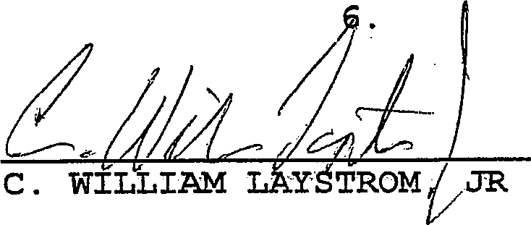
Respectfully submitted this 6th day of January, 201



ITEMS CORRESPONDINaTO SCREDOLEB-111 ;'-'⁷v-:.⁻1".!:'⁻"ZONING INEORMATiON⁻7,7-⁵';7=7⁻'rl
Tet 0.0v,v00.04.01,A0:0“,smancoto xrcaLL00x040617,0 000.1A0u00,0 0 Tara a Ira a.
010.10:MAIRAM
0.¹¹a.A...noznloAAA11*.a.:411110.12.9..A............... ...⁰⁰.00.⁰⁰....¹⁰0.rnasrm.200.4¹(
to.:a
1110•00,11000/0101001.../ATTALAAWA ADM
- 0.4 nt.....01.01111.0. 0.441100,14‘. f0.06.+.0.10y
Aely1111.1210AAA 110 7111r=021140.1.0.1A0010 RAM 00 PAM NAM.
0 ªl=07"44.0.14,7....0=.111.e.0 rel,10..0.07..0.4c010..,1310
STOAMASAMIRVCRIARC01701,10 • LOTITO 001.1001010.01.
- Om ans.. 0⁰ 00¹.AAA WAWA= 01101.01TAADIAIATE0 00301010.010.0.
13.p.......a110.5.111sanstfleat 140.0•A Oftallheedlifal=0. .01,60,000116.00.411,110...A09.00.1".. 0.11,1151. 0.04 Otalleme.
1111111101.01.11 1101007,02.10,00,11010.01005 001/0.1.00ALE MAMA.
_{O}rum is= ommenk r_{o}teas.:1400•0010. .0.40romeno 1•001,100.7
naMemileAeOmbronnalh.r.
30.4.204.00A.
11.14 MAAS At AAA. 0.0010,1011.01‘0100.00110 RAMA VAKAIVA.
no.
@ 0.01C00.1.1.1. NATIKA
ak.10.e...... M.o.. MD /we. Tua
nu(anzenlaz unransemoortart. Hamra anosaarmo Marna. MINA ntak
- renpor.1401.1..11==lAt0t0.A.A1T An MAMA, At ZAMA rporgamwAmorre.
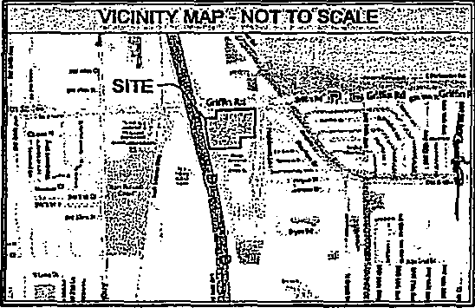
⁻-"MiSCEDIANEtiUtlitoTEt
CD AC ARAM PROP4110.0.A.A•10 AitAne.1.0.0
.004 0000000100 AVE l'EX15.5 00:4:71•0315A4A11‘01000401f0AAAF0110,11117.I00 04.a.TABE AMA. 0,001.000010 SIALALREAAACATEp_{o}r
0).40161.0AAAS,0(1.W.1101000.1.0.0001110 KOK A MAMMA
AEA MAIO GAS. 00/0.7.0110LAIS MAMA 000.00,0111.1.0AA0
CD MARA MAO T1A ALISSURVA ARFOR10.0 /1101,4 C01001100(13 exaraoa
ISARIPOS 3114.011.01FAAA SULDONDIE LAURA RAU Of MT 1.0A pr_{ZZ}ATAS.B.AVYAAAIIT.RDIUMAILLAMIM,ATWAMPATISAAM
_{e}, APIASOF 5000000* AAVAILISIAMOPRCAPIT.
01E.Mr...0
_{e},„ MA AL.. _{F}=1,110. AMT. ZRA0 WIZ MO 1.7. 511117. $.10.111. MARA
et. 090 SYRA(15 HOT 11(101.0,00 COMAPATAI. COM0.11.100 Or..500 AMA.
e, ;7112111=0110010P1410%TrAT0 '180=4";24611 1/01.1 TAX NAM (WAWA AMUR( 23.011
€0 kr WAIT 0117:1=01.70.0.0.0 /0,101:Alif AIWA= A 0,141..T.OBARABLE, GROM AffigrA l0,44.71,10 INOADROVA MAP
COWAN. WPM MAME PLA1000370 10.11010.1•11,01001,A0A0019 MAR
AfItagAl£LOATA10,1110AMARAIDAAVAA AMA ON IA MIMEO pROARIT.TA MOAN TAANIZMAL ASIAN 1141• AY AMA 111£ DAYNA/A011[0.1.
OaMAR t0E OF AAA 0101A04110 0001VAMAZACE A 411010..44.0A. AMA 00,611.A.1.011.40.1:001019. AAA.. SIAA 31.MATAMBAUV4ALOAAre FAMED MA.5 Ix
AAA la Kr°, IAT taPA AMAJAA EMMA. AAA INACAAAAAB.
eg, AAA TWe WITVATIAL sO OestAAA MA. 3.112 MGM 1.01, ASTANAPAA WAIA,MIAL AOIMORKIKAAY. THAMAATORWA 1.414161.0109 A.M.! AAA MOM
CD107 AMA OROMMAXIMOO 0117)1.1AVATAAVAITY411AAAAA WAWA 01114E RAMA /1101111A MO AMOMANIX AYALLIRDIALAT 10011.1) TIAAVEAD AM-WA 6.40A3CLAKCAA PAAAAA LLAAAMILACE TiA00010.011402A01.1.1
ER, 11ANANIALIA AHIM PI mr.semnarmenuAarrAAArtnArr
7A, AMAX= 00,31AAIA BLIMAAAAMMAIAT.
⁷11
,.⁻•:',,giTRECORD⁷DESCR1P.T1OWPON11NUED;,73".'2 .
REVpION'RECORD | e'S GNIFIOANTOBSERVAllONS4=;„

111. CIAO 04,..10100,041,3.10014 A10.110,10 RAO .0.RuCAATE OM 03011.7•10.1 am LAACIAM
IAA AWAIT. BY BOAAl CAM CORP.
IRA ...NAM masa aooaasca moose, vas. NAG mo DAME AAA
ON.. MAMA
' /0010,111,0003 0 .1..7400.111:00 )0ZALIAMAZ 6110.11. TKAIDLAA0.1 All.PCOAT ZAMA° AIWA 0 AA.= 01,000.10/...•Z==r1.0r7,1..
..... 711AUCCIIA ArALA HAM 17.ARALAROKIA50
oanousartaaaao et moans mama Arano...., ae imam...As au.... MA..
P000:00010 020001.0.11.01i.
<1.0.4110.0e. 0.0004111,0001%. 0 AAA.. Norm salmon,. AAA. 11.31MALA0.100
ARP0040.0 00000•01.01.0 AO A /1.000LLMAX CARICOALAIIVA00110 ,
.11/0/A10113A00.0.1101400ALT P.11,000.70.10011:00,0.00040. 000.010.0 I WAAL OD AG.. en I AMP=
-,/
0100.0 0110
^{s} •LEGENET OF VMBOLS⁻VABBREVIAllONST^{-.}1
ANA KA AanesAutect 0 tAAJLAuknott
man. a iAA WA( [KA MAHON'
0.-•00CC DIr 0 GA AN.AL
0 MARC 0.00.1 1511 VOor 04 GA...
0L0111.0101 $0.1.5 KREA S wauAut
43 0t1D7PC TAW AANIKVAD MAW
111.001000n 0 101000014001 011.1103 CPO SADA
13 A.0010.00*1 nwAcA
o 11.110010..0a DC vans ouve 011 Gccao
fl AVA0A1.000.1. A 000000.0 0000P00
ep A0100‘ a AuAAA101.00 1C, GAMMA
G Slam 0,10.1.010".S .ARAWCA IP, PAT
Szr.,04 caw AL⁻T 3r041.0,APAA1A PC 'AA
0 It / CLLL RICCA.
tool/two-a
0 001001 .0011 0 In01.1.0 P. ruiaaaa
SETAARA MOS AP ⁻247. PAR Of KASS ED 0.T. /LORA CA.A0.10 0 A 00A0A0 01,1.11.000I1011011 00.1%.1011,0
111 eicw 0000110011.
AAT11.01.0111
pow a
.aoaa moa, _{o}w.. a a.,
""11.^{"M"} o dat s a rata reer
11310, 11.1,. 0** 0 [Warm 011100.0nA* 400 0 01.070010,
104.....0.0.1.0s nom. 00.01.me. 0.1240./.108.0016.0.1051.0.
horsw 1*.
maamor•ve
1.A2 Loule 0110.0....00.0re Aremnb acour0 0 AC ADA WM
Patol.
A ma ant,*
.040.1.61.10K•art,1203.21.6.A0*.a..s....011004Alsaret ADA Mk AP .1.....rad,AnomfbemeAgnonn•PAAAISAenso-LIALId. o A*1 tem* s A.11.30k Mt atm nelleamasaMmeRSA*A.In.en,a.a, 601: sot m...p pap.01...00.• p.:00•00weAAPAA0
At LAOS SAVAI.BHONIAA DESAANALAARVI.A.01.0.5 A MAMA 1/1 • AATIA.0001709(1,1,0006011.1000101ATAPAMI*Ada...0010.R0a, ASA. MADA/0.4 AA.
A CORD ⁷DESCRIETIONT:
1,10.......n*G.

AS a A Mu,
Pup
/km gr. V' AA0.01.0.• L.Acr40....1Y,••••................n....c....11.401.20
er 41, onsuc • .1Alto ..a.0,203:1•44•IyAAAmet
1.20.84+0 ur.tyt
Comemn....Marammem • Asc.,: ar y *en
Aarrnat
•
WY. 60,•17,..."1=4 R.I...
000**010001100*0C01k03000l.003fl.1lS
:71.7 • W ".7.7 t
*"" erg ••
*"."'*...."...'...."...".1'''".."1:*""11,••• MAP.. I. •
ALTA/ACSM:LANEITITLESURVPr
Sheraton at Ft. Lauderdale Airport Project
/AC Profeti /ha 201400901, 001
Rola
itas 521110 Road, Pinta, FL
RASE. UPONITRE ORDER NO. 47,1130
OF FIDELGYNATONAL TRIE INSURANCE COUPANY
BUM* AR EFFECTIVE DATE OF APRILS, 2014 11d10 PAL
A.V barmy. PAPA,.
MC. 040...0041.10.0*.{.170. 1•10A.AU. ItC, 00.01101A000090011.C.00030/0 Coinparf, GOA Dada 0tach1.011/01.,
ANAass Im*K1 1.1. lamp, Ahm1.4•13.2.114.1A • cat,AjAnAleatLAAA,....
A. .comuno.
.01.2411A00.0910101.412.4.1001000010ALT.C.1.0070080.00⁰⁰1
*al ass Klai.dayariaaeo ova •aalado. Ana 1.2.3, aa ea 7..70.7a a.a. 00loo, 11n94. 14.191⁷.1⁶.09 0421 CT.060.amaat Toowaantas car000so
090010.11351; MEN CERnernaarms UAW OR T. WAWA! SAWA Pit,RFAE1000.0.00.20571..0.11AAOAC0.0/40.051:Ort 01111.1.01 111ESATEOFFIA.01,560F00.181,1•0 FLOR10.13.10 AIWA SURVA0110.
Puadlard117Pawn10.0PIVEACaca dranfrEs CroarpiS/470,1119 14.00sA73406asma00ECCOE.
PRELIMINARY
1.1.40100200
000010011111110.0.S0*
IN 110000A001 Roma,
DATE00R000SU000CA40001aAs1
001EOF1A070E10920000127.2011
MAMMA A1076. SNAIAA.,
StA/A
130.4 OJACOAA MAW AA MACE CAM AREII
F100oeI14i00 000160110000
IMSIIMAACATAIMA MA OF SELO BANA.1•101. °AA A SWAN.
1/111 vaa0911HOW⁻11£9CAMIRE GOT. Cia0aALIAGO °FA
_{va}damuceof arewErAtale_{.w}ao17.„
000( A.AK | Got

PDF croatad pel1Facaayuial axsaal
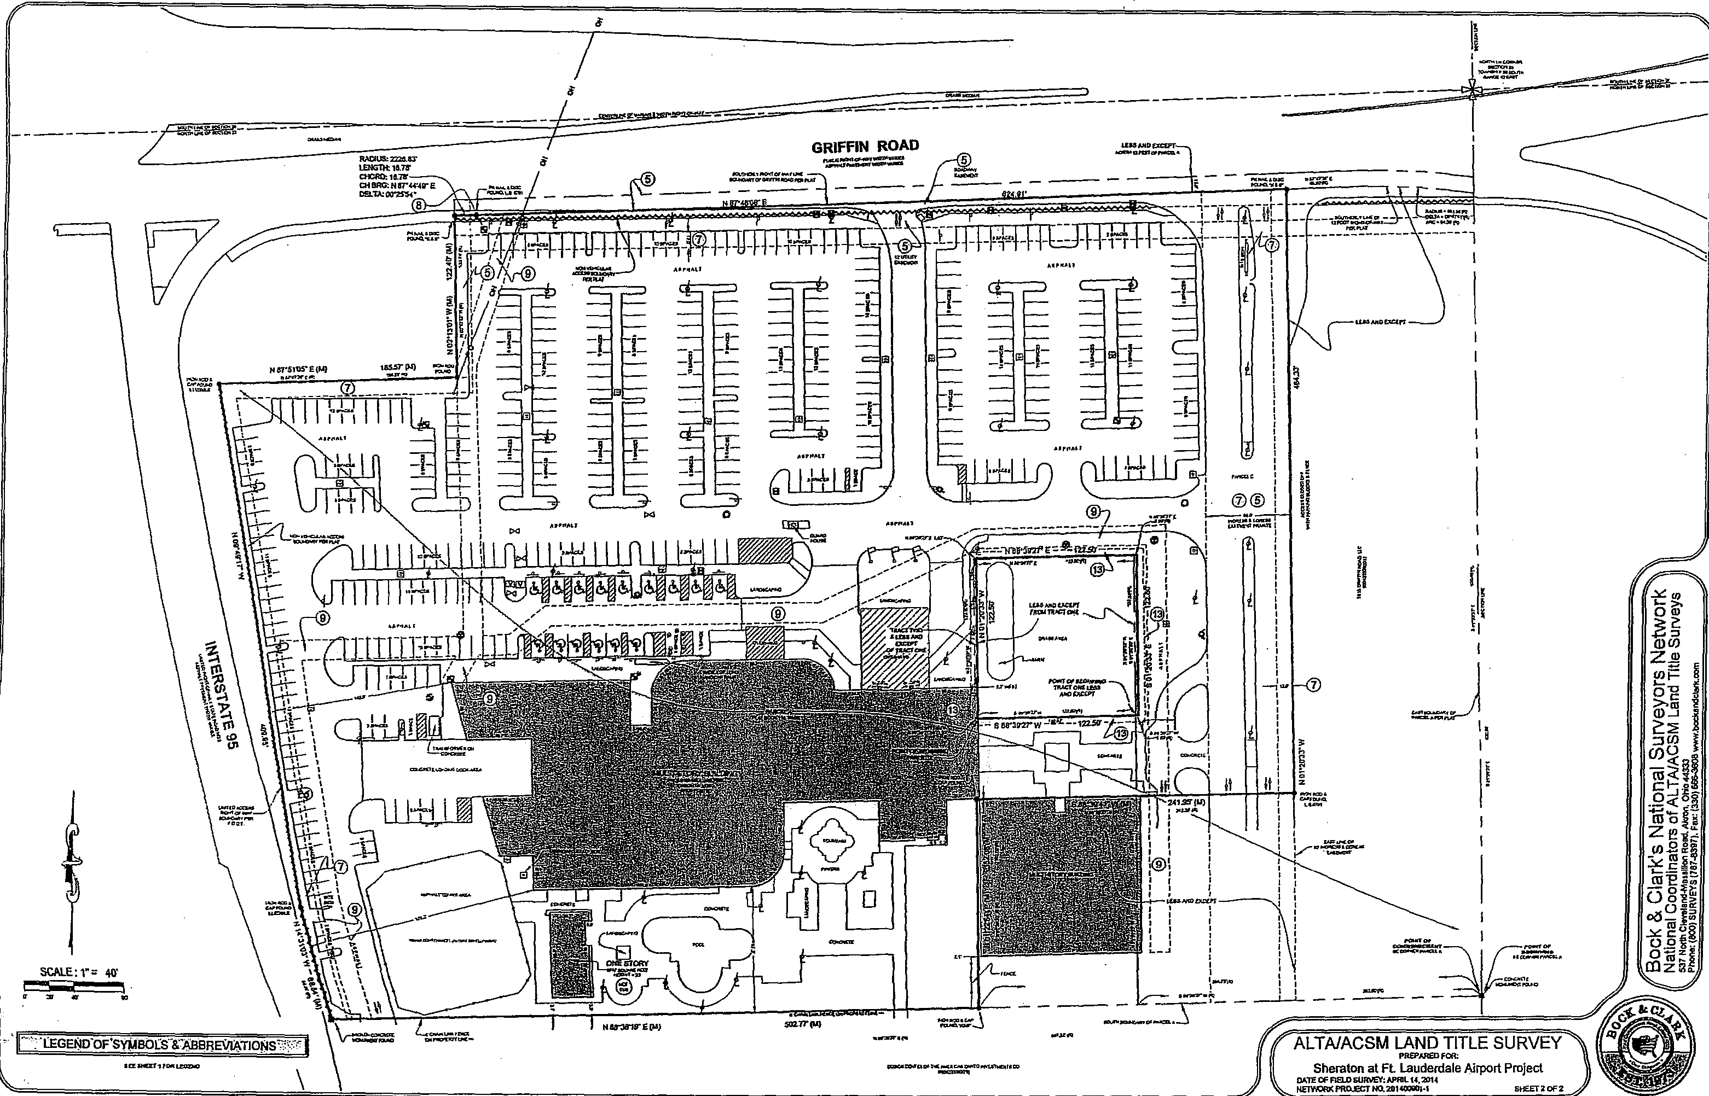
'11—:.LEGGiVOF'SY141301:STABBFIECIIATIONr.f:',⁷:
ALTA/ACSM LAND TITLE SURVEY
PREPARED FOR:
Sheraton at FL Lauderdale Airport Project
OF FIELD SURVEY:APHIL14.2714
NE7WORK MX= .70.201C0001-1 611F-ET On
- - —
-
GRIFFIN ROAD
1.911,191919
"⁶!:=!"
z
199
®

tr.r4-
-⁻-⁻rrer5re
It
124(U)
...corscur
99191.
SCALE:1" 40.
P 9 9 03.
itnIV
*TO
WM, EM
50217114
••¹99
PDF ape. pcdFaclory trial wrsicn
 | City of Dania Beach, Florida  Department of Community Development  Planning and Zoning Division  (954) 924-6805 X3643  (954) 922-2687 Fax

Standard Development Application
- Administrative Variance
- Land Use Amendment
- Mat
- ReZOning Date Rec'd:
- Site Plan
- Special Exception Petition No.:
Variance
CI Other: (SEE APPLICA770N TYPE SCHEDULE ON PAGES 3 & 4)
THIS APPLICATION WILL NOT BE ACCEPTED UNTIL IT IS COMPLETE AND SUBMITTED WITH ALL NECESARRY DOCUMENTS. Refer to the application type at the top of this form and "Required Documentation" checklist to determine the supplemental documents required with each application.
For after the fact applications, the responsible contractor of record shall be present at the board hearing. Their failure to attend may impact upon the disposition of your application. As always, the applicant or their authorized legal agent must be present at all meetings. All projects must also obtain a building permit from the City Building Division. For more information please reference the Dania Beach Land Development Code Part 6, Development Review Procedures and Requirements.
Location Address: 1825 Griffin Road
Lot(s): Parcel B Block: Subdivision: Plat Book 118 Page 11
Recorded Plat Name: Design Center Hotel/Office Complex

Folio Number(s): 5042-33-36-0010 |  | Parcel B of the Design Center Hotel/Office Legal Description:Complex Plat (Plat Book 118, Page 11)

Applicant/Consultant/Legal Representative (circle one) C. William Laystrom, Jr.
Address of Applicant: 1177 SE 3rd Avenue, Fort Lauderdale, FL 33316
Business Telephone: ⁹⁵⁴⁻²⁷⁰⁻³²²⁶ _{Home:} 954-581-1738 E-mail address: blaystr om@aol. coin | Fax: 954-525-3423
Name of Property Owner: Cohen Dania Beach Hotel LLC
Address of Property Owner: 1825 Griffin Road
Business Telephone: 954-762-3400 Home: Fax:
Sign Variance as part of Site Plan Amendment-
Explanation of Request: Hotel Renovation For Plats please provide proposed Plat Name for Variances please attach Criteria Statement as per Section 62540 of the Land Development Code.
Prop. Net Acreage: Gross Acreage: Prop. Square Footage: 569,597
Existing Use: Hotel Proposed Use: Hotel
1 of 4
Is proPertY owned individually, by a corporation, association, or a joint
venture?
AUTHORIZED REPRESENTATIVE
I/we are fully aware of the request being made to the City of Dania Beach. If I/We are unable to be present, I/we hereby authorize
(individual/firm) to represent me/us in all matters related to this application. I/we hereby acknowledge that the applicable fee was established to offset administrative costs and is not refundable.
I/we are fully aware that all approvals automatically expire within 12 months of City of Dania Beach Planning and Zoning Board or City Commission approval, or pursuant to the expiration timeframe listed in Part 6 of the Dania Beach Land De lopme t Code.
STATE OF FLORIDA


COUNTY OF BROWARD The foregoing instrument was acknowledged
BEFORE ME THIS DAY OF
By
By.
(Owner / Agent signature*)
20 1(0

2 of 4
C. William Laystrom, Jr.
(Print name of person acknowledging) point  Notary ¹1⁶-t, | owner signature if applicable)
(Print name of person acknowledging) point  Notary ¹1⁶-t, |  | ......  ?*: ' | KATHERINE ROBERTSON  * z MY COMMISSION # F 131121
(Signature of Notary Public — State of Florid& |  | ' | EXPIRES:.July 19, 2018  Bonded Notary Public Underwriters
Personally known or Produced Identification
Type of identification produced: | or Drivers License

*If joint ownership, both parties must sign. If partnership, corporation or association, an authorized officer must sign on behalf of the group. A notarized letter of authorization from the owner of record must accompany the application if an authorized agent signs for the owner(s).
NO APPLICATION WILL BE AUTOMATICALLY SCHEDULED FOR A MEETING.
ALL APPLICATIONS MUST BE DETERMINED COMPLETE BY STAFF
BEFORE PROCESSING OCCURS.

City of Dania Beach
APPLICATION TYPE AND FEE SCHEDULE
of 4
INCOMPLETE SUBMITTALS ARE NOT ACCEPTABLE FOR REVIEW AND PROCESSING.
The following fees shall apply to all applications for land use plan amendments, rezoning, special exception use, variances, site plans and other zoning related applications. These fees are used to defray staff cost in the evaluation of the proposal made and provide for the required notices and public advertisements according to Florida State Statute and the Dania Beach Land Development Code. should any applicant have more than one type of request to the City, the applications involved should be submitted at the same time. The present City policy is to have concurrent reviews being processed before the final review and actions by the Planning and Zoning Board and/or City Commission. It is the obligation of all applicants to review the appropriate City Codes and design standards related to their proposal before making any application to the City. The standard review process for all development applications are two (2) review cycles. Any additional review or public notice required by staff or professional consultants due to the incorrect interpretation of the Land Development Code will be charged to the applicant as per "Section 685-10 Cost Recovery for Development Review" of the Dania Beach Land Development Code.
APPLICATION TYPE  _ | FEE
LAND USE _
Assignment of Flex Units or Acreage  _ | Filing fee = $4,000.00 plus $5.00 per flex, reserve or LAC/RAC unit or hotel room or $100 per acre or portion of such area  Includes Staff processing, 2 review cycles, advertising and notice costs
Change of Land Use  . | Filing fee = $7,000.00, plus $500.00 per acre or portion of area Includes Staff processing, 2 review cycles, advertising and notice costs
' ZONING
Change of Zoning (Rezoning) | Less than 2 acres - $2,500.00  Greater than 2 acres - $6,000.00  Includes Staff processing, 2 review cycles, advertising and notice costs
Zoning Code Text Change | Changing the list of Permitted Uses - $6,000.00  General Text - $2,000.00  Includes Staff processing, 2 review cycles, advertising and notice costs
PLAT | (Perimeter) Filing fee = $2550.00 plus $50.00 per acre or portion of such area  (Subdivision) Filing fee = $2550.00 plus $100 per acre or portion of such area Includes Staff processing, 2 review cycles, advertising and notice costs
Delegation Request | $1,500.00  Includes Staff processing, 2 review cycles, advertising and notice costs
SITE PLAN
Residential, Hotel, Condo-Hotel, Time-Share, Motel | Filing fee = $1,000.00f $10.00 per unit
Residential, Hotel, Condo-Hotel, Time-Share, Motel | Plus retainer for staff/consultant review, administrative and notice cost $5,000.00
Residential, Hotel, Condo-Hotel, Time-Share, Motel | Minimum fee = $6,100.00  Includes Staff processin,g, 2 review cycles, advertising and notice costs
All other uses | Filing fee = $1,000.00 PLUS the following:
All other uses | $5.00: 100 s.f. for 1st 10,000 s.f., $2.00: 100 s.f. in excess of 10,000 s.f  Plus retainer for staff/consultant review, administrative and notice cost $4,000.00
All other uses | Minimum fee = $5,500.00  Includes Staff processing, 2 review cycles, advertising and notice costs
Site Plan Revisions | $2,500.00 - Includes staff processing and up to 2 review cycles.  Additional variances associated with any revision to a site plan are charged according to the associated variance type.
Extension of Approval(s) (Site plan, variance, special exception requests) | $1,250.00 — Single Extension (PLUS) an additional $ 250.00 for each associated approval

City of Dania Beach
APPLICATION TYPE AND FEE SCHEDULE
INCOMPLETE SUBMITTALS ARE NOT ACCEPTABLE FOR REVIEW AND PROCESSING.
The following fees shall apply to all applications for land use Plan amendments, rezoning, special exception use, variances, site plans and other zoning related applications. These fees are used to defray staff cost in the evaluation of the proposal made and provide for the required notices and public advertisements according to Florida State Statute and th_{e} D_{a}nia Beach Land Development Code. Should any applicant have more than one type of request to the City, the applications involved should be submitted at the same time. The present City policy is to have concurrent reviews being processed before the final review and actions by the Planning and Zoning Board and/or City Commission. It is the obligation of all applicants to review the appropriate City Codes and design standards related to their proposal before making any application to the city. The standard review process for all development applications are two (2) review cycles. Any additional review or public notice required by staff or professional consultants due to the incorrect interpretation of the Land Development Code will be charged to the applicant as per "Section 685-10 Cost Recovery for Development Review" of the Dania Beach Land Development Code.
SPECIAL EXCEPTION
SPECIAL EXCEPTION (Excluding cell towers) | Filing fee = $3,700.00 plus $200.00 per acre or portion of such area Includes Staff processing, 2 review cycles, advertising and notice costs
SPECIAL EXCEPTION Cellular Towers) | Filing fee = $4,000  Includes Staff processing, 2 review cycles, advertising and notice costs
Additional Resubmittal  (In addition to the standard (2) review cycles) | Any additional review or public notice required by staff or professional consultants due to the negligence of the applicant will be charged to the applicant as per Article 685-10 Cost recovery for Development Review of the Dania Beach Land Development Code.
VARIANCES, APPEALS & WAIVERS
Administrative, Single Family | $ 300.00
Administrative, all other | $ 500.00
Single Family/Community Facility | $ 490.00
Duplex | $1,050.00
Triplex | $1,150.00
Multifamily, Hotel, Condo-Hotel (per variance) | $2,300.00
Nonres. (per variance) | $2,000.00
Wall Sign | $ 700.00
Monument Sign | S1,200.00
Pole Sign (As permitted) | $2,400.00
Appeal (single family &. comm fac) | $ 650.00
Appeal (all other uses) | $1,925.00
Dumpster Appeal to Corn. Dev. Dir. | $ 200.00
Dumpster Appeal to City Corn, | $ 500.00
Alcoholic Beverage Variance | $1,250.00
Mobility | $1,400.00
Trafficway Waiver | $4,000.00
Vacation — Road/Easement | $3,500.00
Alcohol Extended Hours License Application | $2,250.00
Alcoholic Beverage Waiver | $1,000.00
Zoning Review: State Liquor License | $ 50.00
Outdoor Seating/Dinning | $ 100.00
Assisted Living Facility | $ 65.00
CRA Grant Application | $ 800.00 (up to this amount based on scope of work)
UNSPECIFIED | $ 500.00 PLUS any outside costs incurred by the city as per "Section | 685-10"

Revised— 8-23-11 As per City Commission Approval Resolution #2011-090
4 of 4

LAW OFFICES
DOITMAR, ALLSWORTH, LAYSTROM,
VOIGT, WACHS & ADAIR, LLP

1177 SOUTHEAST THIRD AVENUE
JOHN H. ADAIR, III, P.A. FORT LAUDERDALE, FLORIDA 33316-1109 BENJAMIN R. DISHOWITZ, P.A.
EMERSON ALLSWORTH, P.A. BROWARD ₍₉₅₄₎ 762-3400 RAYMOND A. DOUMAR, P.A.*
E. SCOTT ALLS WORTH, P.A. TOLL FREE (866) 242-9488 C. WILLIAM LAYSTROM, JR., PA.
MARK E. ALLS WORTH, P.A. TELEFAX (954) 525-3423 JOHN D. VOIGT, P.A.
WEBSITE: SFLALAW.COM JEFFREY S. WACHS, P.A.+

+ALSO ADMITTED IN PENNSYLVANIA OF COUNSEL
.FORMERLY ADMrITED IN MICHIGAN JOHN W. PERLOFF, P.A.
JODIE SIEGEL, PA.

December 16, 2015
Re: DCOTA Hotel Renovation - Sign Variance
COHEN DANIA BEACH HOTEL, LLC
RESPONSES TO CRITERIA FOR SIGN VARIANCE
The applicant currently has an application pending •to amend the site plan of the existing Sheridan Hotel located at 825 Griffin Road to provide for both interior and exterior remodeling and to re-brand the hotel as La Meridien Hotel. As part of this site plan amendment process, the staff has identified one or more variances which the applicant will need to seek in order to accomplish this new plan.
Specifically, the applicant is allowed to have one wall sign on the north face of the hotel building only. The applicant is seeking to permit a second. sign on the south face of the building in the same location where the existing sign is. As part of this request for a variance, the city must consider as part of its determination the following criteria:
(1) Whether the special conditions and circumstances exist which are peculiar to the land, structure or building involved and which are not applicable •.o other lands, structures or buildings in the same zoning district;
Applicant's Response: The subject hotel is located •at the southeast corner of Griffin Road and 1-95 within the DCOTA development. The building faces north fronting Griffin Road and has the allowed sign on the north side of the building. This sign is visible from both 1-95 south bound and Griffin Road traffic heading in either direction. Currently, the building has a sign on the south side, which is the only sign visible from northbound traffic on 1-95. The applicant would submit that the unique location of this building next

to an interstate highway requires signage on both sides of the building so it can be identified from motorists on 1-95 passing in either direction. Since the subject use is as a hotel, adequate signage is essential in that many customers of the hotel will be from out of town and will be unfamiliar with its location and will be relying on signage to locate the hotel. The fact that the applicant is only seeking to replace the old sign with a new sign is also unique in that the prior signage was approved and the size of the proposed sign falls within with the city's code requirements.
- Whether the special conditions and circumstances do not result from the actions of the applicant;
Applicant's Response: Since this is an existing hotel with existing signage, the current applicant cannot be held responsible for the special conditions and circumstances concerning the location of the building next to Interstate 95 in the orientation of the building to require signage on both sides. Further, it appears that the special circumstances were approved by the city and extra signage granted as part thereof.
- Whether granting the variance requested will not confer on the applicant any special privilege that is denied by this code to other lands, buildings or structures in this same zoning district.
Applicant's Response: The applicant would submit that granting this variance would not confer any special privilege in that the signage is already in existence •and the applicant is only seeking to replace the existing sign with a new sign for the new hotel brand. It is not believed that this would in any way grant anything special to this applicant that would be denied to other similarly, situated applicants.
- Whether literal interpretation of the provisions of this code would deprive the applicant of rights commonly enjoyed by other properties in the same zoning district under the terms of this code and would work unnecessary and undue hardship on the applicant;
Applicant's Response: A literal interpretation of this code
provision would deny the applicant any signage on the south
elevation of the building. As a result, there would be no
signage whatsoever visible to north bound vehicles on 1-95. This would certainly constitute a significant hardship to the applicant for the operation of hotel on this site and an undue hardship to the applicant does not serve any purpose to the city.
Whether the variance granted is the minimum variance that will make possible the reasonable use of the land, building or structure;
Applicant's Response: The applicant is seeking the minimum variance in that it is seeking only to replace existing approved signage with a new sign for the new hotel brand. By seeking essentially what the applicant already has been granted in the past, the applicant feels that the minimum request is feasible under the circumstances.
Whether the variance granted will be in harmony with the general intent and purpose of this Land Development Code, and that such variance will not be injurious to the area involved or otherwise detrimental to the public welfare;
Applicant's Response: Allowing replacement of existing
sign on •a large hotel building should clearly be in harmony with the general intent and purpose of the Land Development Code. Further, the signage will in no way be injurious to other businesses or residents in the area and will simply identify the hotel and its location.
Respectfully submitted this 17th day of December, 2015.
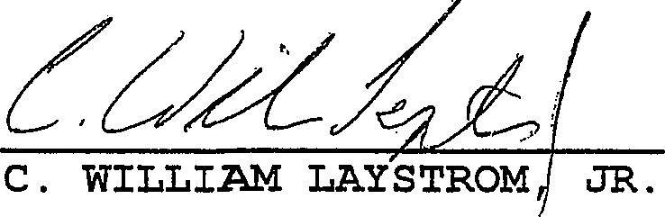
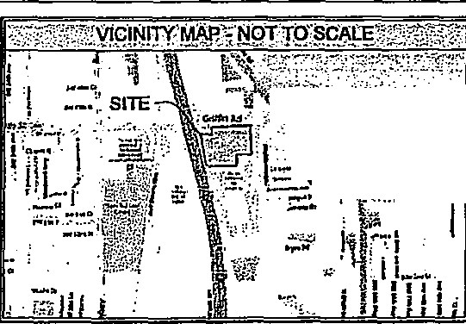
11 ITEMS CORRESPONDING TO SCHEDULE B-II

ZOIING NFoRtivaloN
=ftvereracl.x01,11.•1.2V77120.. rtratuArconIOUTHE.7.111•1
t17-:7=
- ^{,1}:SIGNIFICANT:013SERVA1IONSW•:)7,
PROJECTREVISION
OCIE
12:5011110.1
IIESITRIARTIN
CATE
110HE AYMILOIT.
ITC147041
retSTINIA.Ft
04•12.1.4
ICIVCAt
03.21⁻4:114
FEYeADTITLE
20I0004122 Icdurrn% CO
6220330 Pr. ITAT ICS
:COPYRIGHT2014;1„f:;'
DOCrt WA% CORA.
TAIS IMPILICT STYLE MA ISPIKATSTAII OACTIVACTITAMIAL PLATS ARE KAMM
TiElISSINIMMI.EMOMMATOSIRCII.TratertaTIMIVrt.IrrigNIVITVIC0111.1011,
IODASSON.LOCXSCLAI.Ofilt
".`F1_001:! NOTE
V GUAM PLOT. OACCIICTRIOPETAT A£ MO) OF ITC ALOCOLIOURAICEACT
f41..20011211722114 0.1.00.1•11.. MS,. 1.1.103110
VaiallIMILTIRIntkttX1 CR PART fait,011•MICIEFROUTFFEFFOOK 1:160:14.
®
PI
cenrreswnsktlau,S, no.m.
.Ans. •A•ms. Ire *as Po* TAO aLeyec7S ANC gyAnTAD
PANCIMAHNIMAIR TAM AAA /s0 ROMA. WATT ITIMIL
®
.••• •••••.......•••••••••••"*. man tal.P...1.4
Talimem.1.171111.M•2770.0/1.77.1111•1.7TO M0.0.
Lt120141TZIAT01.1.001/Imporall IZTT CNA. 4...0 WS
11⁷.¹.71.121.SURATEDMOPOITY.1211.1•Wirto..1011.060.
INESUR21/1.101.11.111311,1.011u1MISNC.11.1014
0, ICI
anonSyuCadMi ISM
1,4
Caldfloze.1.393,pq•
nos mime., umcnomorar4A.E.AEE.E.EAE.E.EE ILEVETEDIE
0 by ...IA poraananow.11106.1now...1...P.
craturra nos.,p ecomen•Ammanert • dam.). van...
Impimftwed.64....011.........s...11eanma era •psnisel
110.12.1“1.11.111114.twileo MIERTI.tiaglen.TIOI.M.101.13711.1.1R.RAT11214.
•
12.7.n.scana n InWhtenand
1.1114, ICC Mt AVIII/771"",MAN.CIICAS ARA AOPIA.A.21.7.1 AT.
@Cmcaz=nr Ortiallsowit.31111 511
LEGEND OF SYMBOLS & ABBREVIATIONS': • II
P..14 PLUM W.. P.
0 MMUS 0 WTAITTE o CLAM..
GAS
G-4 V.1
e
_{A}M.P.P.f.DaNacra
02020224 5/4/.1...11POLA
4.- -Can NNE
EtKiffie..." 0] MAT
MM. MEM sr+ oarco,
Icx01
IIIVOICAva 110.106.41.1.1.
CONOITTACA f.
MATTA VC.
MM.( 1101.../1 IRE nr aura
CC ....rut wawa Gam..
smus.olun wow. vonTinuAkKkt (P)
81081....r uoulewr.sonlii PC IV.
22220220 222222042222203
42 WITASCIATA e 3.2242200
0 Tt.f...=,'"- 2222222020 ⁰⁰⁰' 'OfTrIAS%=
011121.1.001.0
.⁻NVOX
CALI.E.O.TES
^{FO}F^{-.....E.}ME‘Pd,FAEIEI.E..E.EIDEESSIESEtSCUSEI
mIsCELEANEOUs'No⁻rEs? -.711
TIE.V.PrOrri. iStlar NA.S.a[9:5370.01.10412.....91.421ZW011...11:0
(..f4rEs 6114.4 an...MUM cuRrrt... .711.y Onfltra sUP.F.EAKO.M.VratOMIX7.421senel...47104, 22291W00 02200. 0 022. 0 3 503OE020001.•1113 Ile 620000 2001 PAW,
TKEIRE 0A.E MO curt 00...0vEntAn.rcalalwenixTIOINESI.R.S0 PROPER7/0.51:11williantilaVAVrerERIONCBMOIMEITILEci.
MUM. 5.11./.1.011ARE Skst..01411.E.TALT Mart or vorett. Oi
C:) ,11741:ATEKIIIMVAND COUNII,Itmortt1110.1.0•4717W.191paig.cog
C) 2222DDRESS OF 3.6PUFOX /1.0022SI05I2000221210121050 rItcalArr. 11•ErrannIOPEArt 20 0000 LiSa .82.30.073 SWAM 00002
MAIM AMAPA MesaPALFS /MOO STRartO HOCCAPpea
1•NUMIGSPMCEIFORAIVIN.OFASI 63AMPAKINO 111•14000111.4.21.
a) VMS a nye( NaTrlff..f.DIPIC..0171=104 On00.171.140020200023050.
Of....6 MAL RaTIP.I....0
E31 SVIIVETOR 11..10.1.21.1WWW101.1.Z.MINrs rap AL7pus74 tAAATITLETATIVATIT CASTAXIIVT AMY. 72.20.)
1.1,0,:_{v}ir_{a}r, WITI.TrALI.....EOUTZTI_{T}IZIELLEXTORIAXATED pf
C.0.701EPTABLA ANIVE AA00111.111.11[1.0.1.0CATIOCA INCIAORCONTILITILTICS
WAKE WW2. AM. CALL .110.1CA etrOMITIAI T.TOCITAIIIIIN COPAN. MI:REVCO ARERA...17004.1IEUTKAY SOOSALC.1.701./...14. APPROMATELOGIWN01,10.11411:.1.0.1,11121.10.1420.1%e 34MATELIPROPERI,Nel•RMILS1,0211WiNtl. (=NW IAT5•11.4 I MIMI. IMTNIVITDUCALL.
61.Way.714.11E1....200sERMILLEveeiMaiD.111111./.1 K
E".3) arlitIVZITZATrgra="17=c,°;"..⁹,t',"ZZ,..
€3, =LTV:, Wer.T.1=0.01.711.....evare. 01,711%.y..0.50. 1.11100217211vad.....MONcta.XV 000.04..0Kvakfrostwae.0...PLAIOr
\INVOWIAIrlft=ltr'"Ar. "'"ASR.Z.Vrt.'""OraNFA
.11112.11VCO Intabrty PIKICRAKMARKG0/17.
PROM1110....14.17(M.W.....007.m/E0.11.4....0.c.DAPORAIION
(a) NniErrtruatfr of tzar. .1 Wear wows.", cOATAAcr
il.:•'''',113EQORD:DE$CRIPTION.001411NUEET¹1.1
70001111,4111:
n:
•••••P.P.,.......t...........⁰¹.runeleT.^{10m}paelor...⁾¹4.^{12.1.41} ollievenr. Ca•soireL Owernevri..06,....1*. wens:al in
le Dedusdan sMorro. Conno.P.orrosaneOpmeng /*m.o. Oa R.ares
,A•pm.
bowes ts...)1 Neural*.
1,1,11•11...art..0.-
T00.01101.4111t
Agroarrat, eat. Orrernlag IteCk...../inwonnwswena.10[4+11.......⁴1010.M17. byArrre*alt.•.ea.*.•••••n••••..•,....:h•••.•••...
vodo.alsdpirionam 1,..1,norrysas sof a...
annytTIO,NOWN...neSeatef....00.......m..CISCAZIEO WU COMM.= WIDEUTIKIITMILLITE NISMANCE.WANCIMMIIKI. fryIMAA77.1".110‘....4.
ALTNACSM1AND TITLE SURVEY
Sheraton at Ft. Lauderdale Airport Project

86003221200 No. 201400901, 001
00031
1826 Griffin RoAd, Dents, FL

- .RFP⁻PRP⁻0⁻000RIPTIQN 'r7.7^{.1}N
MN AAA LANAA
hIs...11.0•••
/me a. n⁻vw4
on.
••,.. (....obre.
/1.=:=1.71,r/ZZI:Z.:411::=========•=4.••
'7,72
In11.4=1...ar Iratra arra LZIPt^{r}esKIM:11.....t...1===1.02.7.4;•••
Tou. et.
C.ms....vara. • in F..
AVArir
was Nans..........01•mar 14..t1.1A3 ffrinsa. 1•••••
mno.rxrn•44.10./,
01.4.7.1101•117ST Into W..*
Amu.
'"."17'...'"...".:T=3:4====.=.71.1rZetr===^{"73}0,⁷1:¹.":^{0"}..' grown
rA :AA
[4..s...tencOnnaton
800E0 UPON TITLE ORDER NO. 476030
OF MELT' NATIONAL 1TTLE INSURANCE COMPANY
SEARING AN EFFECDVE DATE OF APRIL 9, 2014 611700 PAL
sum,
Ts Weep Pummel T. iroumhorComp,,Bp.us (UM Lax...Porpol
U.. ACCAEl MORF1.11.10,117....uom
LI.C. • ovm.Imuclbenr,....,, Ca. ow, au. 0004022
pona me way o.n.o.. II maLlinaccoano.
risn5021110.....srar3 OGIJAWACSI...m1•115.....,
.222302205100.02231.T1530lI*fl,22040000 urns 1. 2.3. 504 747047,44
124 704 04 37.141417. 141522721 *1.0. 0030.022 T1*100**0T0*.*10M*3333P2 14.2D1/
L..6. LBO; 0ERE47 0E07171, TUTU. SKETCH 0117710000100²000 5.00007 1.7116.11311....7511.1.190J1.¹ TECH14.1.61,HDARDSFC.19-.VEMODI INESTAIE OF FlOr604455E7FORIII 137 FLOA77A 0.1007 .11:171.17.11,04S, MAW/ 70.7.37737.72077.71.07110.4 5747LRES CHAPTE114,4717771. R0120.0.1.2457114177EC004
PRELIMINARY
10ARICGASS7
1793471.710.1...517 SOS
117711E577.07 71.0111%
D1122DEflflOSMIOF.040310&014 DATE DELAsTEEMEtt RA, 27,En 1.7401.P203001e07.7,014.01.1
Wave, 1.4:0414087:
10040.47.007141.11.
840,7EGOL077.51x7E4
5474507,14. =AO
100774741323 FAxampls.co
7/7.443.41.7795/01100470CLA050000
laSSURVOIS cERTIFIEDIDIVJE OF FIELOSURVE7. 001 0000 04 000421100 07.0110.1.00711E Snt1471.01E MO 77E 017.1.71.5E0 MAL 071
TOO
\1.......\11:070.071:115170SuRVE70177.14.71£17.
StlErr
aoc.ccAPEPRosEETHE =n.02
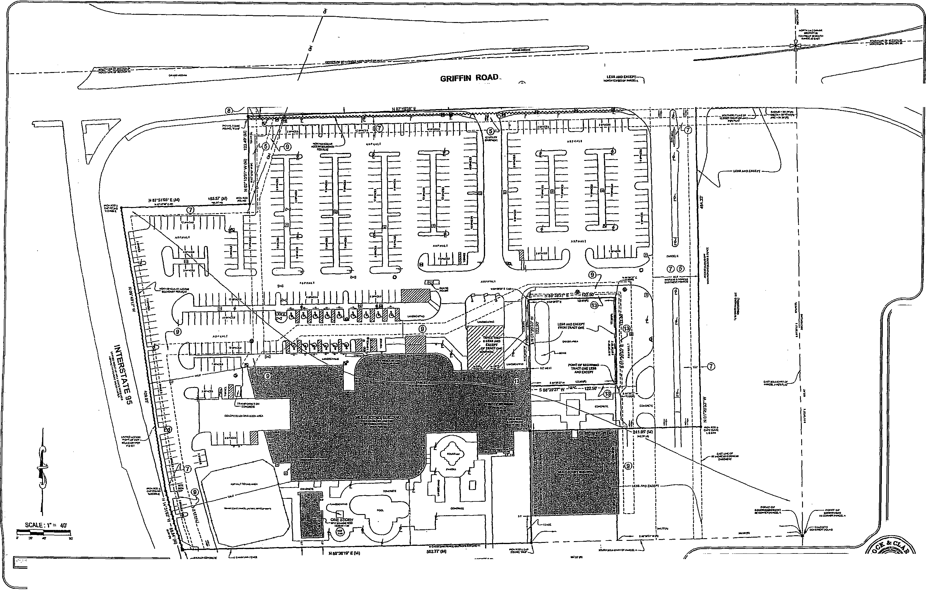

LEGEND'OF'SYMBOESWASSREVIAtTIONS

RAC111.2523.67 LENGTa16.7, CHOR0:1031( .811G:Ner4or Mak 62.2S5r
3i•
z.
PP 3
c>,⁻E
²
no)
WsZqi
o;,⁻z^{I}ga
Zto U)2 ec2
(Cr° '^{It}
VE v 0E> ...„0
Z!!!
0⁵§
o
0 t--
oizI

_{C}/ALTAJACSM LAND TITLE SURVEY)
PREPARED EOM
Sheraton at Ft. Lauderdale Airport Project
ONTO OF nraD SURVEY: AP21.14,2011 NEMOR0000.ECTN0.201403,70,1 SHEET x OF
PDF creelethveth pOlFociory versicon
 | City of Dania Beach, Florida  Department of Community Development  Planning and Zoning Division  (954) 924-6805 X3643  (954) 922-2687 Fax

Standard Development Application
U Zio o Li 0 o a | Administrative Variance  Land Use Amendment  Plat  Rezoning Date Reed:  Site Plan  Special Exception Petition No.:  Variance  Other: (SEE APPLICATION TYPE SCHEDULE ON PAGES 3 & 4)

THIS APPLICATION WILL NOT BE ACCEPTED UNTIL IT IS COMPLETE AND SUBMITTED WITH ALL NECESARRY DOCUMENTS. Refer to the application type at the top of this form and "Required Documentation" checklist to determine the supplemental documents required with each application.
For after the fact applications, the responsible contractor of record shall be present at the board hearing. Their failure to attend may impact upon the disposition of your application. As always, the applicant or their authorized legal agent must be present at all meetings. All projects must also obtain a building permit from the City Building Division. For more information please reference the Dania Beach Land Development Code Part 6, Development Review Procedures and Requirements.
Location Address: 1825 Griffin Road
Lot(s): Parcel B Block: Subdivision: Plat Book 118 Page 11
Recorded Plat Name: Design Center Hotel/Office Complex

Folio Number(s): 5042-33-36-0010 |  | Parcel B of the Design Center Hotel/Office Legal Description: Complex Plat (Plat Book 118, Page 11)
Applicant/Consultant/Legal Representative (circle one) C. William Laystrom, Jr. Address of Applicant: 1177 S .E . 3rd Avenue, Fort Lauderdale, FL 33316
Business Telephone: 954-270-3226 Home: 954-581-1738 Fax: 954-525-3423
E-mail address: blaystrom@aol.com
Name of Property Owner: Cohen Dania Beach Hotel LLC Address of Property Owner: 1825 Griffin Road
Business Telephone: 954-762-3400 Home: Fax:
Variance from Section 510-30(H) regarding minimum Explanation of Request: required glass facade For Plats please provide proposed Plat Name for Variances please attach Criteria Statement as per Section 625.40 of the Land Development Code.
Prop. Net Acreage: Gross Acreage: Prop. Square Footage: 569,597
Existing Use: Hotel Proposed Use: Hotel
1 of 4
Is proPertY owned individually, by a corporation, association, or a joint
venture?
AUTHORIZED REPRESENTATIVE

i/_{w}e are fully aware of the request being made to the City of Dania Beach. If I/We are unable to be present, I/we hereby authorize
(individual/firm) to represent me/us in all matters related to this application. I/we hereby acknowledge that the applicable fee was established to offset administrative costs and is not refundable.
I/we are fully aware that all approvals automatically expire within 12 months of City of Dania Beach Planning and Zoning Board or City Commission approval, or pursuant to the expiration timeframe listed in Part 6 of the Dania Beach Land Detelopmçnt Code.
STATE OF FLORIDA
COUNTY OF BROWARD The foregoing instrument was acknowledged
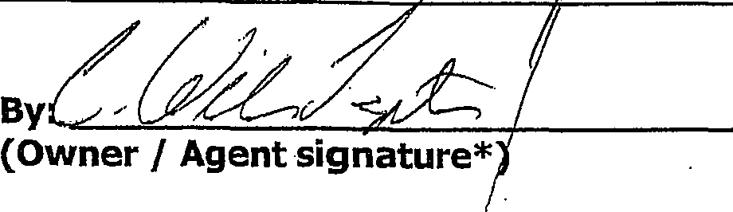
By
(Owner / Agent signature*
BEFORE ME THIS ( ^{L(ik} •DAY OF  By:  C. William Laystrom, Jr. | 
(Print name of person acknowledging) •(Joint owner signature if applicable)

Notary c4146 (¹c42,4
0^{.1}4.i'?.. KATliERINE ROVEIRTSON
Aki
. ',LA MY COMMISSION # FF131121
,.
Ira
' ¹.. ..k.% EXPIRES: July,19,,2018
Banded Thru Notary Politic Undemiters
(Signature of Notary Public — State of Florida_

Personally known >( or Produced Identification
2 of .4
Type of identification produced: or Drivers License
*If joint ownership, both parties must sign. If partnership, corporation or • association, an authorized officer must sign on behalf of the group. A notarized letter of authorization from the owner of record must accompany the application if an authorized agent signs for the owner(s).
NO APPLICATION WILL BE AUTOMATICALLY SCHEDULED FOR A MEETING.
ALL APPLICATIONS MUST.BE DETERMINED COMPLETE BY STAFF
BEFORE PROCESSING OCCURS.

City of Dania Beach
APPLICATION TYPE AND FEE SCHEDULE
3 of 4
INCOMPLETE SUBMITTALS ARE NOT ACCEPTABLE FOR REVIEW AND PROCESSING.
The following fees shall apply to all applications for land use plan amendments, rezoning, special exception use, variances, site plans and other zoning related applications. These fees are used to defray staff cost in the evaluation of the proposal made and provide for the required notices and public advertisements according to Florida State Statute and the Dania Beach Land Development Code. Should any applicant have more than one type of request to the City, the applications involved should be submitted at the same time. The present City policy is to have concurrent reviews being processed before the final review and actions by the Planning and Zoning Board and/or City Commission. It is the obligation of all applicants to review the appropriate City Codes and design standards related to their proposal before making any application to the City. The standard review process for all development applications are two (2) review cycles. Any additional review or public notice required by staff or professional consultants due to the incorrect interpretation of the Land Development Code will be charged to the applicant as per "Section 685-10 Cost Recovery for Development Review" of the Dania Beach Land Development Code.
APPLICATION TYPE  _ | FEE
LAND USE _ | _
Assignment of Flex Units or Acreage | Filing fee = $4,000.00 plus $5.00 per flex, reserve or LAC/RAC unit or hotel room or $100 per acre or portion of such area  Includes Staff processing, 2 review cycles, advertising and notice costs
Change of Land Use | Filing fee = $7,000.00, plus $500.00 per acre or portion of area Includes Staff processing, 2 review cycles, advertising and notice costs
ZONING
Change of Zoning (Rezoning) | Less than 2 acres - $2,500.00  Greater than 2 acres - $6,000.00  Includes Staff processing, 2 review cycles, advertising and notice costs
Zoning Code Text Change | Changing the list of Permitted Uses - $6,000.00  General Text - $2,000.00  Includes Staff processing, 2 review cycles, advertising and notice costs
PLAT | (Perimeter) Filing fee = $2550.00 plus $50.00 per acre or portion of such area  (Subdivision) Filing fee = $2550.00 plus $100 per acre or portion of such area Includes Staff processing, 2 review cycles, advertising and notice costs
Delegation Request | $1,500.00  Includes Staff processing, 2 review cycles, advertising and notice costs
SITE PLAN
Residential, Hotel, Condo-Hotel, Time-Share, Motel | Filing fee = $1,000.00 PLUS $10.00 per unit
Residential, Hotel, Condo-Hotel, Time-Share, Motel | Pius retainer for staff/consultant review, administrative and notice cost $5,000.00
Residential, Hotel, Condo-Hotel, Time-Share, Motel | Minimum fee = $6,100.00  Includes Staff processing, 2 review cycles, advertising and notice costs
All other uses | Filing fee = $1,000.00 PLUS the following:
All other uses | $5.00 : 100 s.f. for 1st 10,000 s.f., $2.00 : 100 s.f. in excess of 10,000 s.f  Plus retainer for staff/consultant review, administrative and notice cost $4,000.00
All other uses | Minimum fee = $5,500.00  Includes Staff processing, 2 review cycles, advertising and notice costs
Site Plan Revisions | $2,500.00 - Includes staff processing and up to 2 review cycles.  Additional variances associated with any revision to a site plan are charged according to the associated variance type.
Extension of Approval(s) (Site plan, variance, special exception requests) | $1,250.00 — Single Extension (PLUS) an additional $ 250.00 for each associated approval

City of Dania Beach
APPLICATION TYPE AND FEE SCHEDULE
INCOMPLETE SUBMITTALS ARE NOT ACCEPTABLE FOR REVIEW AND PROCESSING.
The following fees shall apply to all _{a}ppli_{ca}ti_{ons} for land use plan amendments, rezoning, special exception use, variances, site plans and other zoning related applications. These fees are used to defray staff cost in the evaluation of the proposal made and provide for the required notices and public advertisements according to Florida State Statute and the Dania Beach Land Development Code. Should any applicant have more than one type of request to the City, the _{a}pplic_{a}tions involved should be submitted at the same time. The present City policy is to have concurrent reviews being processed before the final review and actions by the Planning and Zoning Board and/or City Commission. It is the obligation of all applicants to review the appropriate City Codes and design standards related to their proposal before making any application to the City. The standard review process for all development applications are two (2) review cycles. Any additional review or public notice required by staff or professional consultants due to the incorrect interpretation of the Land Development Code will be charged to the applicant as per "Section 685-10 Cost Recovery for Development Review" of the Dania Beach Land Development Code.
SPECIAL EXCEPTION
SPECIAL EXCEPTION (Excluding cell towers) | Filing fee = $3,700.00 plus $200.00 per acre or portion of such area Includes Staff processing, 2 review cycles, advertising and notice costs
SPECIAL EXCEPTION Cellular Towers) | Filing fee = $4,000  Includes Staff processing, 2 review cycles, advettising and notice costs
Additional Resubmittal  (In addition to the standard (2) review cycles) | Any additional review or public notice required by staff or professional consultants due to the negligence of the applicant will be charged to the applicant as per Article 685-10 Cost recovery for Development Review of the Dania Beach Land Development Code.
VARIANCES, APPEALS & WAIVERS
Administrative, Single Family | $ 300.00
Administrative, all other | $ 500.00
Single Family/Community Facility | $ 490.00
Duplex | $1,050.00
Triplex | $1,150.00
Multifamily, Hotel, Condo-Hotel (per variance) | $2,300.00
Nonres. (per variance) | $2,000.00
Wall Sign | $ 700.00
Monument Sign | $1,200.00
Pole Sign (As permitted) | $2,400.00
Appeal (single family 8/, comm fac) | $ 650.00
Appeal (all other uses) | $1,925.00
Dumpster Appeal to Corn. Dev. Dir. | $ 200.00
Dumpster Appeal to City Corn. | $ 500.00
Alcoholic Beverage Variance | $1,250.00
Mobility | $1,400.00
Trafficway Waiver | $4,000.00
Vacation — Road/Easement | $3,500.00
Alcohol Extended Hours License Application | $2,250.00
Alcoholic Beverage Waiver | $1,000.00
Zoning Review: State Liquor License | $ 50.00
Outdoor Seating/Dinning | $ 100.00
Assisted Living Facility | $ 65.00
CRA Grant Application | $ 800.00 (up to this amount based on scope of work)
UNSPECIFIED | $ 500.00 PLUS any outside costs incurred by the city as per "Section | 685-10"

Revised— 8-23-11 As per City Commission Approval Resolution #2011-090
4 of 4

LAW OFFICES
DOLTMAR, ALLSWORTH, LAYSTROM,
VOIGT, WACHS & ADAIR, LLP

1177 SOUTHEAST THIRD AVENUE
JOHN H. ADAIR, III, P.A. FORT LAUDERDALE, FLORIDA 33316-1109 BENJAMIN R. DISHOWITZ, P.A.
EMERSON ALLS WORTH, P.A. BROWARD ₍₉₅₄₎ 762-3400 RAYMOND A. DOTTMAR, P.A.
E. SCOTT ALLSWORTH, P.A. TOLL FREE (866) 242-9488 C. WILLIAM LAYSTROM, JR., P.A.
MARX E. ALLS WORTH, P.A. TELEFAX ₍₉₅₄₎ 525-3423 JOHN D. VOIGT, P.A.
WEBSITE: SFLALAW.COM JEFFREY S. WACHS, P.A.+

+ALSO ADMITTED IN PENNSYLVANIA OF COUNSEL
*FORMERLY ADMITTED IN MICHIGAN JOHN W. PERLOFF, P.A.
JODIE SIEGEL, P.A.

December 29, 2015
Re: DCOTA Hotel Renovation - Sign Variance from
Commercial Design Standards, Section 510-30(H) COHEN.DANIA BEACH HOTEL, LLC
RESPONSES TO CRITERIA FOR VARIANCE FROM
COMMERCIAL DESIGN STANDARDS, SECTION 510-30 (H)
The Applicant currently has an application pending to amend the site plan of the existing Sheridan Hotel located at 1825 Griffin Road to provide for both interior and exterior remodeling and to re-brand the hotel as Le Meridien Hotel. As part of this site plan amendment process, the staff has identified one or more variances which the Applicant will need to seek in order to accomplish this new plan.
Specifically, Section 510-30(H) requires that the ground floor of a commercial building such as this hotel be comprised of at least 35% of glass windows and doors with regard to the primary elevation. The site plan modification submitted indicates that the existing hotel has a 27% glass coverage on the ground floor and, therefore, requires a variance of 8% from this design standard. As part of this request for a variance, the City must consider as part of its determination the following criteria:
(1) Whether the special conditions and circumstances exist
which are peculiar to the land, structure or building
involved and which are not applicable to other lands,
structures or buildings in the same zoning district;
This is an existing hotel that was approved with this amount of glass and door coverage on the ground floor. The hotel is being remodeled and it is both impractical and virtually impossible to increase the amount of glass

on the ground floor. The Applicant would note that every other floor of the building greatly exceeds the amount of glass required for the ground floor or for the floors themselves.
(3) Whether the variance granted is the minimum variance that will make possible the reasonable use of the land, building or structure;
- Whether the special conditions and circumstances do not result from the actions of the applicant;
Since this is an existing hotel with existing elevations that are only being remodeled and modernized, the current Applicant cannot be held responsible for the special conditions and circumstances which led to •the original approval of the hotel and its existing design. The special circumstances were approved by the City, so the Applicant would ask that the approval be granted a second time.
- Whether granting the variance requested will not confer on the applicant any special privilege that is denied by this code to other lands, buildings or structures in this same zoning district;
The Applicant would submit that granting this variance would not confer any special privilege in that the building is already' in existence and the Applicant is only seeking to modernize the hotel and change the hotel brand. The Applicant believes that this would in no way grant anything special to this applicant that would be denied to similarly situated applicants.
- Whether literal interpretation of the provisions of this code would deprive the applicant of rights commonly enjoyed by other properties in the same zoning district under the terms of this code and would work unnecessary and undue hardship on the applicant;
A literal interpretation of the code would require the Applicant to essentially rebuild the ground floor of the hotel. Since it is an existing multi-story building, this is not feasible to undertake under the circumstances of the site plan amendment package that has been submitted.
The Applicant is seeking the minimum variance in that it is seeking to only maintain what is currently has and not to expand the variance.
(6) Whether the variance granted will be in harmony with the general intent and purpose of this Land Development Code, and that such variance will not be injurious to the area involved or otherwise detrimental to the public welfare;
Allowing the hotel to continue as is with a remodeling should clearly be in harmony with the general intent and purpose of the Land Development Code. Approval of the existing elevations will in no way be injurious to other businesses or residents in the area, since it is an existing hotel.
Respectfully submitted this |  | day of January, 2016.
 |  | (Z,1
 | C. WILLIAM LAYSTR


r3C4S7nn"{Or••:=1 ªOrtr"Rac:274=•7"====.

p. ITEMS CORRESPONDING TO SCHEDULE•134Ir:.
®
®IY310.7 •• nOneig Roans
numern
PROPHIV.11001MRIMRCARCIO•s0M•LE ^{T"'""""'"}
soya amta...1.1.11.eartm 1.41.10. ▪ N. as elm,
wesnarteRasearr•/0........05.•,..•...1.6.0•• 3...114⁰3.3.3001.3.2.1.0•30•007.3 oPton00 00301
0 iltm.0.01.1.4.0.1.11.12.1.p•WW yAleis • Cm) TM
IMIAPITSTIMIR MOVED PROPORT.0(013.1719 NO P.M IIEREVOL
0 • trware,....nalerachr 1.t.Compu,.....4. Caliamnrea 17⁻11,•• U0 millattlamolp• to.1.2.pr T30 Vi•O•P•rual• One end 1.1.1103170.01.C17 IRE SUM= PROPOITT AMO PLOTTEOPX0.01.1.10.
ZONING1NFonw,o1oN:,
11.311avel. VAVgliPP.I.O.1113...M.KM1.1.1111ENSORII.V1110.7112 TAKIAIIIEUala
WSCELLAN7 "EOUS⁻NOTES
CD 1303310.0_{...n.} 330.M N.03.smocrn.c........0.1030.001 rtr.0.14...c=n0szpa.23.3.0of Of soo3
SLMOKE M4INOrcOursoineuCia. Lc4126.
03.033001.03 000303.0010.303 101000000000 101010100 60003 CCM 111.0. 'MOE.. atm.. 0.03.00
C€:. MOM. 3.0 00 THE .03333.3.30.00.3011.....30.3
110.30.
000101113010.03.330.3HE 03170.3.3 Orwo L. of
Vr..) jr:1116.111.6.031A1M11.01.701.41110T.ITW.PER MAT WOK.,
0.10.00013907i.01,00-03.330000POS.0111.300.11110800E077.
770 000700,.10 0008000..00..Fs30110460e5.0 01000001
110REARR .6710PEO REGULAR /ARAM •PACESMOSSSIMPE010...1,9E0 I. 0 EPP.OESPORA RIX Of An STRIPED PPACIMI "DONT. SURVEYED
- PROPERTY.
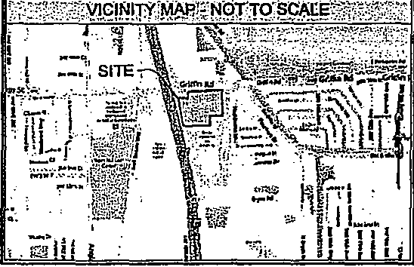
NicINITyMAPliNOrro:OCAll
RE.d6RtildEg .ORIOTOW
trAs AGGIAGEPI:
1.0114,r7r P.2•1*0261.0.• • Emma Or LI
•••••M•wM a.** hms 3.04.• 20 ³³.0,³*0
=."70.7•70======.1=1"e.'"= g== '10, • • 3603.3.1000...3
Haw,. G.ap
0.3.1033.0.0....... 0..3.
t'21"17•1==== '•••=1191: =It': It Zte=garrr
0.33G³1,
:===.........1=mn4.03..0.3.0m.......•^ H... 0.⁰.
G.31.11,;174,G.303.
6.11.071,7.ne
TITatiNeR ran:
- noon. In rokia now.. 100.P•• •Inntir, ono., 41.•
MagnAPIX.•••••00.11.M.Y.11.0.• 4111.4.11=1141.•
3..33.3”......0
00.11,110.41.140 a WI--

0⁰.0001/0“.11.%0:0,0•30.0.1Romalk.3,417.P•i•E4
5.3330.,... 033. 010. 3.030.01.2. Hp. 0.^{0 3,}3⁰⁰.0 ROM= IllteCTSTIE NWT. PROPORY,rnitRE AR MO MITA. MYR MOS
@ :Tomo.= acnowna=rzvalomwerosulv woman. es ••017.0*
nan....IRroma 114.12.1,21 &rem Anuenva OR...
Cownwajsmonan era ppronpApnwonemereoa Ora bseautwo1=6,...”:,.. marr.•,......enommeas.,1,......e..,[der,rn
- nia,•nacy, woo
bra Y1 opp.....racrn.... mt ps man 04.1.aannula *co *pat
P**•••• 0,••• Push 0,Tow rrt.14'.711 11.0rIrreo
ITIOMITY.ROVEVfn MAIM! 11.1070.2“ SLPVIIMS.
12. Twan dna
Su.........••••• .11.1.17.11,Na 1.4
IIIMMICTS TIM.= ItCrIATTMEVIA TKIWARIMMOTIASU RAM
V: Pam MHZ 737.30,001,'"' "7"r3i".
@
313m.
LEGEND OF SYMBOLS & ABBREVLAllONS
1333123010 19 TWIG G.... 0 3.0110G GOGGLE
NYE . 11.41.0.17 POLL CUM 0.
WA. UCalt 0 GASLI.,,E el 410. luxx.L E.E1100 001111 o.p0000L, e .3.MR
Ill 333000000007 .1 TONER ₆ NANPOCAPron•A10.4
TaMSPCRNER 0 001000.•10 1011.100s.0100
Ci
1.00010R t^{'s} EL. K.
SI G,MGYEAustGai 114 0011110012 10, RE .40
- .30330 0101.300 .0. foe 0..urt OH
- sat IX ...UM. wroaurt
NONA WIAN0000a.o Q00000*o*000r ‘3, HAr
SI D •..11.0erPREV0010 PG PA.
³¹⁰.¹⁰Er.33.003 vGren,GlIn OH op
O 13(303 8 wzo. xtx,
tf par 10.n _{A} m a = PoVrt Of F G⁰0: ⁰:001.⁰ :::
- PAMENT Of 7100000007001. OTNIANUERD
no...0.0003.
OH
GUS 3000E1 7070I0000700 c0a30100000103 GONSTRUGGGY GUM PURPGSP.A.
(E) g^{E}a011.74=11 so'⁻'117',ErZttirta"tr'^{n}'re
00000308013 00001404000010107
43000007 00_{Ivrat}00_{p}...._{Z}0300IE00004700100073001
33.3.0303.20.00.11.0..0323033.3.030.110..0003030.01.133ME3 1:ES1 3.33.0.330. IONOVICAL OA*. 00300.000o..0.03.,Hurr ...3WHERETOU. _{c}irreNOTA 00.73E WOW 3.3331.C.300 TO Jo.
303.171r"'"':'' UT """ZZTOATS•04Y1 SOMME
010A0777Y00001L
giltg=t7,7₄11=.. Malall_{.s}aS.V.LEENDINCEMCAMILKI.G.0(4,
C) a:UV.= "%77."'"''""
21111=7.1r"'¹⁰⁰'O⁸"'"`""T"..=."⁰⁰²⁰⁰⁰'
IIIMILINV,IGAV.30107 PROMO GGPaUJITATIM MO! A.. MG
P.112,[6.1901.1.W.11,11.UNACt MY. OM.. BY BO[g [411%07.0141. 1₁₁411e. r_{E}Z₀:101.1Mi OF 1.1.0.0.70 BF IN FrtECTIMPUOMMTNIC0107.1 nor kou000070 PL(VIMMEOLIIVIMEIMEIT.
IREpORD OESCRIPTFONOONTINUED
IMMO WM P.11 B:
oC,o.10I000.110000poal1000100108000q0M extp0.110•01:10101”..0 pputlelane Wand 0.8 las eirles•1=0110•16.1104domeal 310.00...3033 3303.0.01.1033.0.0.34.......3.3,33301.0331.00.03,3
p30. ard .0060.43.1.....31.31000 0003.0.6.10.03.3.010.
.30 33310300.H.H.0300111010313.3.00 reo...13.0.3...333.30.310
0030003 31000034 ⁰³.⁰.⁰³....³.⁰³.⁰⁰³,⁰⁰⁰9⁰.⁰⁰⁰.⁰.³ WHOM pip 327,10
pet, rol pop. gy man pa (....20.1..1.11.1.1.47..M.pniqm.
u.tlarutl Nave. sift... Cannams oar Wins ...ram.,
loy•Inprealitika• •Ms.na..
104ETNI.R.Ilt
01”............euan ri.....melo•••art.......1,••••••••.P...P.,.......
.,,iu^{r'''''11:}Reerel••,..7¹......,..^{ndt'}ll"....4^{4."}::7•0•^{."."7".L}I'"'":77.1^{."M.}•15..".'ruel7R•aceft^{.:'"".:":1}•7.**Cm0⁼=^{7":}..'...."'"*.:::::::^{*P}::: M⁰P.,......urerr we Ermeneribmandaes.01•.0eseet..67ncl On, b....ft.
ING1.105 Suitveno.S.XOGG IGO Maclean testa4GteGGIMIELGG r, .pf.SOGIEDGI 111.33.0.003MHPROVOLO er Mort 3.3132.7.......3.0,0303.0.
ALTA/ACSM LAND TITLE SURVEY
Sheraton at Ft Lauderdale Airport Project
MSC proi.ct No. 201400901, 001
Hotel
1825 GrItfin Road, Oronla, FL
131.83 UPON 1111.0 ORDER NO. 4754130
OF many NATIONAL VILE INSURANCE COMPANY
BEARING AN EFFECTIVE OM OF APRIL 2014 ell:00PM.
To F.30 H.000+113. 00.3. Ca00.: 5.3 30. HO) HO FL l.3 .³⁰.00.³3
- • ⁰.⁰+³⁰ ⁰⁰³.⁰⁰⁰/ 00.0.³0.31 HOTOFUALC, 003.03.3.³3³⁰/
30.03.00.000.03; Conan OHH.33.001003. Or.. Oa*. 1.0100 03000,3310...0.010. 03030.10.0. aDdroweir.1133. 3000.3 8303 033.33...
- 0030.0. map or341 and. 033,0 weicrOth 10 ma 3..00 30333.3
.nnaomst
0.01rducka 1.0 1. 2, 0 3. 33. 03.33.331.
10▪ 3.103,130 33.13.10.17. It 10 400 LI 013. 3.1.3or.110 0.1.1.0..
30341.1 .
A
13,201.

ALSO:
PDF efea.1.011p0WOOCy100133.0nal
1,301036.1303,1300.03.3013⁻111.3.5 SKETCH CA THE BOUNDARY SUPAY REPPOSEHTED HEREON 30.3.01.00.031ECH13.“13333.5.009 FOR4.00.114
10010000 OF 10.0100.4ASSET 00033100THE 31.00.103.00.103 WOO ^{800,017000}PUSSAHTTOCHOHER 0011.1.1045TATHIES MO CHAPTER 5017 OFIHE ROMA 3.0130.30.311VECOCO.
PRELIMINARY
- 005⁻11351100 PSI SSW
21114E STATEOF RM.
11A1E °FREED SURVEY:AM 14.201.1
- 001.3.3300/1.3.0 MY Tr. 0331
HEIMAIPX PRWECTN0.2014.01.1.

. :FLOOD NOTE ":"
SIGNIFICANTOBSERVATIONVgni::
RECORD:
OKIE
033.03.03
OESCAPTICal
MO TOW 00 I can= ZS
CHECKE0 int I 101
WORM. KOMI° 001Y.1101PROPERIT •470.0.E M.TA,THE PICO. .9...0KERME
LIA.P.00=1/0 .=4, vap morn cos sac./ trVEMEISCEOP
0.119.⁰30.3.0.3.0 MOM oto11003,.m.......03 0.3300301.3 ...00.11TJOOLICIAMMVPAROCTE_{L.} •CTNE7FOC.V. h.110.333=0.•
VERISIT.DETERIAMOMCI• APPLY MR .1110•COROWINEFELIERY. 0.00.7
133⁻00.300rn23.003
1•ElviCRX
044.2ape
FOSTIF.Arr
07 004 &0.011I10000.
INISPROOLKTSTRE MR., 13 PROM/ED BYCOP00.0,10 AM..= ARE RESERVE&
THEM OF 11113 STYLE P110 IS ITMLTLY PROW070216000WITIEWRIMI COMM=
PET011.00 Of DOCK...PARCORP.
NONE APPAMOrt.
SURVOr PERFORLE0100
DOCK/ CURNCORP.1.0.3303 BM MAME COURT.SURE 3.3.603.3.01
- M0:0.¹.⁰=⁰S 10,11011.43
EU. 303.1.0030000.300.0.10.0¹.¹
- 3 3301VMS CO31.01310 13. OF ROD HOT DATE OF 500.51.0.
tOT VATIOUT RE SIGHOUPEAHOT3E OAS ED SEAL Of
KOPHAUCENSEDSLOVEV0.01...f.
SHOET1OF 3
0003 MA. MOE= H0.02013[0132

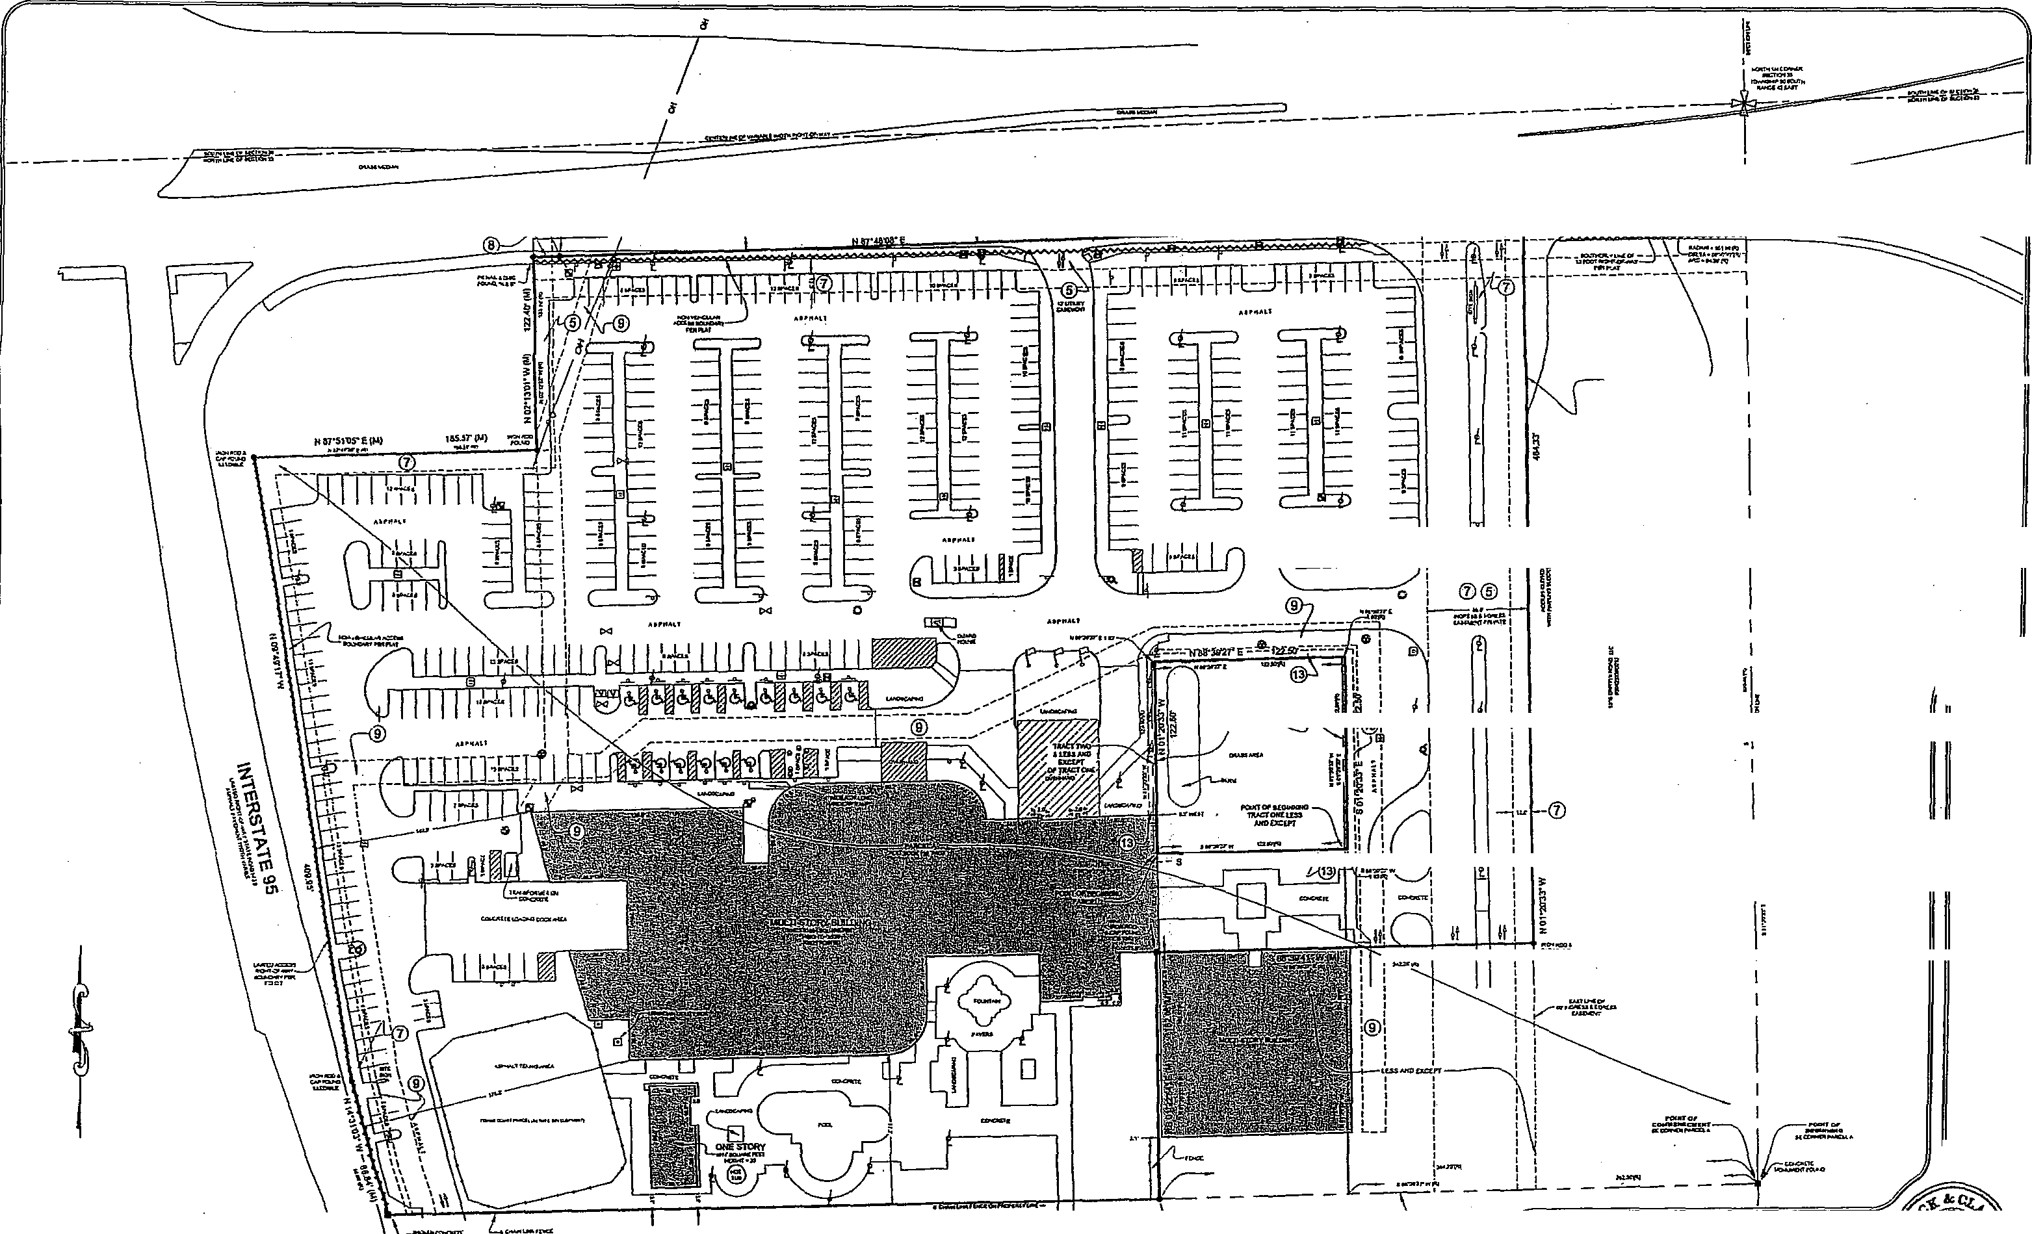

GRIFFIN ROAD
•=7.7,==:
MOM =SAT LIENGlIt 101II
Ot CHM Ian
BM, NIT,Virr RELIC 00.253e
14.6.00LE.11
.....
nIHf
Me Ma UM/
IFTCMINCIPIL
!'

013-1P27. — —wart —
=477,1,"

241.95. (IA)
SC.ALE: 40'
a Yr 02
0 CO
7
_{E}
^{F} 1^{1,}
0¹³
>,7₃ 3
2 A nu)
j <8 (ER °Z(^{V}9a
fir*
ULM
C§41 fibe
Z⁻g
c
0.2 0*:'
z shf.
xenalr E
502.7111.1) =Z.
1.....,LEGEND-OESYMBOLSA ABBREVIATIONS .
tee weL1110..Lania
PDF .alodwigualFactory oialversionw. ratlegra,,CM
rALTA/ACSM LAND TITLE SURVEY
PREPARED FOP.
Sheraton at Ft. Lauderdale Airport Project
DATE OF FIELD SURVEY:APRIL 14.2014 HMV.< PROECT NO.201.0014

